Table of Contents

What is DNS? 4
How does DNS work 5
4 DNS servers involved for webpage loading 5
Difference b/w Authoritative DNS and a recursive DNS resolver 5
Types of DNS queries 8
DNS caching 9
Browser DNS caching 9
Operating system OS level DNS caching 10
Ransomware Explained 10
Prevention of Ransomware 11
Removing it 11
Facts & Figures of Ransomware 11
On the decline? 12
Should the ransom be paid? 12
Ransomware examples 12
Internet Protocol Version 4 13
Addressing 14
Allocation 14
–HIGHLIGHTED ON PAGE TRANSFER LATER 14
HTTPS vs VPN: why you need both 15
HTTPS shortcomings 15
First access unencrypted 15
HTTPS can’t encrypt with single click 16
HTTPS can’t protect against phishing 16
End note 16
Back to Basics: Multi-factor Authorization? 16
When to use MFA 17
What is Phishing 17
First phishing lawsuit 17
Common features of phishing emails 17
Preventing Phishing 17
What is encryption? 18
How it works 18
Cryptography 18
Types of encryption 18
Reasons for encryption 19
Common Encryption Algorithms 19
Jail break encryption 19
What is the CIA triad 19
Confidentiality 20
Integrity 20
Availability 21
Applying the principles 21
OWASP TOP TEN 22
CVE Vulnerability 23
DDoS Attacks 23
Get the most out of the bootcamp notes 23
Community-based learning 24
Being a resourceful problem solver 24
Patience 24
Course details 25
Intro to Cyber Security 26
Brief history of Cyber Security 26
Modern Day 26
Role of cybersecurity 27
Fundamental principles of Cybersecurity 27
Governance + compliance 28
PIPEDA 28
PCI DSS 29
OFSI 29
ICSs 31
Types of Cyber Attacks 32
Why do we need Cyber Security 33
Protect Against Cyber Attacks 33
Computers and Operating Systems 34
Brief History of Computers 34
Kinda know already - Get to Know Your Computer 35
Introduction to Operating Systems 37
Three OS dominate Personal computing today 37
Components of OS 38
Ports and Hardware Security 39
Myths + Facts of Hardware Security 39
Get to know your Port 40
Legacy ports 42
Vulnerabilities and Risks of Buttons and Ports 42
Securing Buttons and Ports 44
What is Binary? 45
Bits and bytes 45
What is Hexadecimal? 46
Why it matters in cyber attacks 46
Double encoding 46
Hexadecimal IP address 46
Intro to Networks 47
Fundamentals of networking 47
How does communication and network work? 47
Different types and how to use 47
Network Components 48
Overview of Protocols 49
Introduction to OSI Model 49
Unraveling each layer 50
TCP/ IP Protocol 52
How it works 53
What is the structure: 53
Characterics of TCP/IP 54
Additional Network Protocols 54
Principal Types of Network Protocols 54
Main Network Protocols 55
Network Architecture 58
Peer-to-Peer (P2P) network 60
Network Security Basics 60
Articles to Read 60
Understanding IP Addresses 61
What is an IP address? (IPv4) 61
IP address classes 61
Subnet Mask 62
****review and go over Subnet masks************** 62
Difference between fixed IP and dynamic IP 62
IP on websites 63
Internet Service Provider (ISP) 63
Cyber Security Frameworks and Roles 63
Team: overview 63
Job: Roles and Responsibilities 64
Cyber Security Team: Aligning goals 64
Choosing a Cyber Security Framework 65
Using a Cyber Security Framework 65
Thinking Critically about Frameworks 66
Cyber Security Framework Components 66
Get to know some Frameworks 67
Blue vs Red Teams 68
Offensive and Defensive Security 68
Role of the Blue Team 68
Risk Assessment 69
Incident response 69
Forensic Analysis 69
Monitoring 69
Defensive Security Measures 69
Role of the Red Team 72
Attempting to breach Walls 72
Fact-finding and analysis 72
Offensive Security Measures 72
Attack Simulations 1
Dev Environment 1
Dev Environment 1
Virtualization Overview 1
Operating System Virtualization 1
EVE overview 1
Virtual Labs and importance of Cyber Security 1
EVE environment - overview 1
Setting up remote Desktop Protocols 1
Intro to Visual Studio Code 1
Intro to MITRE ATT&CK 1
Intro Video recommended 1
Article to read 1
Intro to Wireshark 1
Uses 1
Readings 1
Intro to PAESSLER PRTG Network Monitor 1
Recommended Reading 1
Intro to SIEM 1
Advanced threat detection w SIEM 1
Intro to SNMP events 1
Concepts & components 1
Intro to Command Line 1
Command Cheat Sheets 1
PKM – look into it 1

Cyber security Notes
pre - pre- prep: https://www.cloudflare.com/learning/dns/what-is-dns/

What is DNS?

Domain Name system (DNS) is like a phonebook for the internet, humans access online info though domain names. While the web browsers interact via IP addresses, Internet protocol. DNS translates domain to IP so browsers can load the information.

Each machine on the internet has a unique IP address so other machines can identify it. DNS servers eliminate human need to memorize IP addresses like IPv$ or newer complex alphanumeric IPs of IPv6

How does DNS work
- Converts a hostname into a computer friendly IP address. (IP is like a street address)
- You type in the initial page request, DNS finds the IP address and locates the proper web page/ information.

For a web browser the DNS query is behind the scenes after the og user domain name request

4 DNS servers involved for webpage loading
- DNS recursor
  - Can be thought of like a librarian - asked to find a specific book.
  - Server designed to receive queries from clients though application of web browsers. Than recursor is responsible for additional requests for DNS
- Root nameserver
  - Root server
  - Step 1 in translating host names into IP addresses
  - Like a library index, serves as reference to more specific locations

- TLD nameserver
  - Top Level Domain server
  - Like a specific rack of books.
  - Hosts the last portion of a hotname… like .com or .ca
- Authoritative nameserver
  - Final step of a nameserver query.
  - If access is allowed, it will return the IP address for hostname back to the DNS recursor that made the initial request.
  - Consider an authoritative nameserver like a dictionary, which has the definition of a specific word.

Difference b/w Authoritative DNS and a recursive DNS resolver
Both refer to groups of servers that are key for DNS infrastructure. But each plays a separate role, at a different location. Recursive is at the beginning and authoritative is at the end.

Recursive DNS resolver
- Is the computer that responds to a recursive request and takes time to track the DNS record down
- Makes several requests till it hits the authoritative.
- Caching is a sata persistence process that helps cut down on necessary requests by providing earlier records of DNS lookups.

Authoritative
- A server that actually holds and responsible for DNS resource records,
- Bottom of the DNS lookup chain
- Responds with queried resource record, without querying another source.
- Is the finial source of truth for most DNS records

Additionally, if the query is for a subdomain like foo.example.com.. Additional name servers will be added to the sequence after the authoritative.
Sub domains are stored in CNAME record

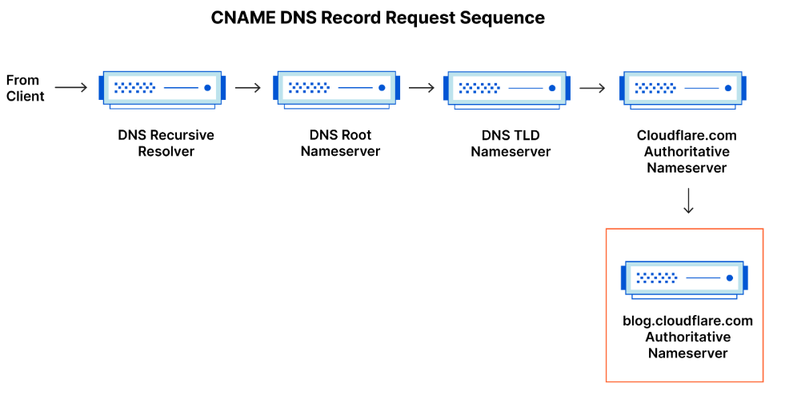

DNS services vs Cloudflare…
Options like google DNS, openDNS, comcast, etc all main data center installations of DNS recursive resolvers. Allowing quick/ easy queries though clustered DNS-optimized computer systems.

While Cloudflare maintains infrastructure level nameservers key for internet functioning.
Example would be the f-root server network.
- Cloudflare partially hosts. F-root is one of the root level DNS nameservers responsible for billions of internet requests daily.
- Uses the anycast network allows for large volumes of DNS traffic without issue.

What are the steps in DNS lookup?
Mostly DNS is domain name translated into appropriate IP address. The DNS lookup information is usually cached either locally in the computer asking for the information or remotely at the DNS servers. When cached not all 8 steps are taken

- A user types ‘example.com’ into a web browser and the query travels into the Internet and is received by a DNS recursive resolver.

- The resolver then queries a DNS root nameserver (.)
.
- The root server then responds to the resolver with the address of a Top Level Domain (TLD) DNS server (such as .com or .net), which stores the information for its domains. When searching for example.com, our request is pointed toward the .com TLD.

- The resolver then makes a request to the .com TLD.

- The TLD server then responds with the IP address of the domain’s nameserver, example.com.

- Lastly, the recursive resolver sends a query to the domain’s nameserver.

- The IP address for example.com is then returned to the resolver from the nameserver.

- The DNS resolver then responds to the web browser with the IP address of the domain requested initially.

Once the 8 steps of the DNS lookup have returned the IP address for example.com, the browser is able to make the request for the web page:
- The browser makes a HTTP request to the IP address.
- The server at that IP returns the webpage to be rendered in the browser (step 10).
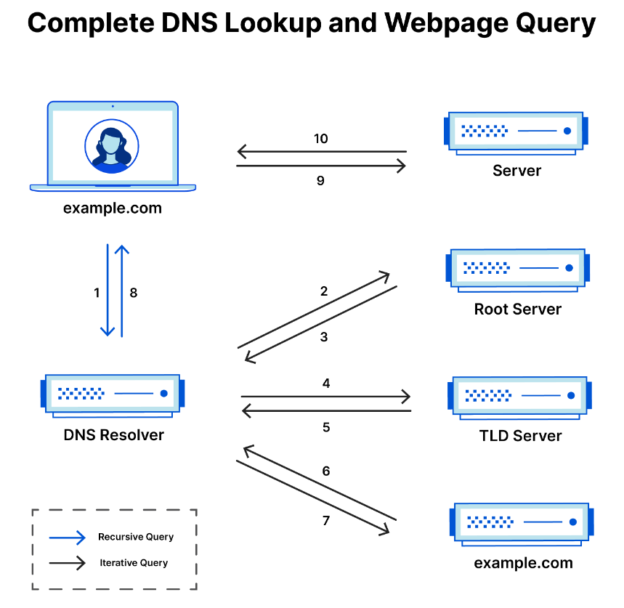
What is a DNS resolver
- Responsible for dealing with the client who made the initial request. Step 1.
- Starts the sequence of queries that lead to a URL being translated into the IP address
- Typical uncached DNS lookup will involve both recursive and iterative queries.

Recursive DNS query: requests made by the resolver needing the answer for a query
Recursive DNS resolver: a computer that accepts queries, and processes the response

Types of DNS queries
Recursive query: Within a recursive query, the DNS client requires a server respond to the client with either requested resource record or error message (if info is unavailable)
Interactive query: the client allows a DNS server to return the best answer it can. If the DNS server does not have the exact match, it will return a referral to a DNS server authoritative → for lower level domain namespace. The client will then make a query to the referral address.
This process continues with the query chain until either an error or timeout occurs.

Non-recursive query: occurs when a DNS resolver client queries a server for a record it has access to due to being authoritative or has a copy in cache. Typically a DNS server will cache records to prevent additional bandwidth consumption and upstream server usage.

DNS caching
Purpose for cache is temporary storage data for improved performance and results. DNS caching means storing info closer to the requesting client, so the DNS query can be resolved quicker, improving load times and reducing bandwidth with less CPU consumption.

Can be cached in a variety of locations, stored for set amount of time determined by TTL - time to live

TTL Time-to-Live:
https://www.cloudflare.com/learning/cdn/glossary/time-to-live-ttl/

Refers to the amount of time or ‘hops’ that a packet is set to exist inside a network before being discarded by the router. TTL us also used in CDN caching (content delivery network)

When a packet of information is created and sent through the internet, there is a risk it will continue to pass from router to router indefinitely. To avoid this possibility packets are designed with an expiration date called TTL.

- The TTL can also be used to know how long a packet has been in circulation
and allow for a look at where the packet has been on the internet.

Each packet has a numerical value determining how long it should move through the network. Each time a router receives a packet it subtracts one from the TTL count. If the count is zero then the router will discard the packet and send the ICMP message back to the originating host.

Common network commands like ping and traceroute utilize TTL

Browser DNS caching
Designed by default to cache DNS records. Closer the caching occurs to the web browser, the fewer steps to be taken to get the right IP address. When a request is made, browser cache is the first location checked for the requested record.

Operating system OS level DNS caching
Second and last local stop before a DNS query leaves your machine. The process inside the OS is designed to handle the query - is called: Stub resolver

Stub resolver: gets a request from an app, first checks its own cache and if the record isn't there, sends a DNS query (w recursive flag set) outside to DNS recursive resolver inside the ISP

ISP - Internet service provider

When the recursive resolver in ISP receives a request, it will check to see if the request is already stored. The recursive resolver has additional functions depending on types of record in the cache.

- If no A record, but has NS records for authoritative nameservers. Will query them directly - bypassing several steps. The shortcut prevents lookups from the root and .com nameservers and helps resolve the query faster.
- If no NS record, it will send a query to the TLD servers (.com servers), skipping the root
- In the unlikely event the resolver does not have records pointing to the TLD servers, it will then query the root. Typically occurs after a DNS cache has been purged.

Ransomware Explained
https://www.csoonline.com/article/563507/what-is-ransomware-how-it-works-and-how-to-remove-it.html

Ransomware: a form of malware that encrypts a victims files. The attacker then demands a ransom to restore access to the data upon payment

User is shown instructions on how to pay a fee for the decryption key. Costs
range from a few hundred to thousands. Often paid in bitcoin.

How ransomware works
Vectors of access
- Phishing spam: attachments come by email masquerading as a trustworthy file. Once downloaded they have built in social engineering tools to gain more access.
- NotPetya: are more aggressive - exploit security holes to infect computers

Most common action malware does once infected - is encrypt some or all of the user’s files. Once encrypted the data cannot be decrypted without a mathematical key known by the attacker.

In some malware, the attacker claims to be a law enforcement agency, shutting down the victims computer due to porn or pirated software. Demanding the payment of a ‘fine’ so the victim doesn't report the attack to the police. But most attackers do not bother with a story. Some automatically spread through the internet (worm).

Simply most attackers: threaten to publicize sensitive information on the victims hard drive unless ransom is paid = called leakware or doxware. However finding and exacting the information is tricky for the attacker.

Organizations are targeted for several reasons, including opportunity, likeability of paying the ransom, sensitivity of information.

Prevention of Ransomware
Good security practices in general are good defenses from all sorts of attacks.
- Keep OS patched up and up to date to limit vulnerabilities
- Don't install software or give admin privileges
- Install antivirus software to detect malicious programs
- Whitelisting software which prevents unauthorized applications from executing in the first place.
- Backup files with an air gap - will limit damage of an attack

Removing it
Will need to regain control of the machine by..
Reboot in safe mood → antimalware software → scan system for ransomware → restore computer to previous state

Will remove the malware but not decrypt data.

Facts & Figures of Ransomware

- Lots of money in it for attackers, $5 bill of losses in 2017 up by 15x from 2015.
- Some markets are prone to it → hospitals and medical organizations which pay low sums.
  - 45% target healthcare orgs
  - Additionally 85% of malware infections are ransomware
- While 90% financial institutions are targeted
- Anti-malware won't protect you. 75% of companies fall to ransomware when running up-to-date endpoint protection on the machines.
- Amount of attacks exploded in mid 2010’s.
- In 2017 ransomware was up to 60% of malware payloads → today down to 5%

On the decline?
Economic decision based on cybercriminal currency choice of bitcoin. Getting the ransomware paid is a hit or miss. The decline has also been matched by a rise in so-called crypto mining malware which infects computers to mine in the background.

Two kinds of ransomware attackers.
- Commodity - try to infect indiscriminately by sheer volume
- Ransomware as a service - platform that criminals can rent and target groups on specific segments and organizations. *more concerning

Should the ransom be paid?
Theoretically no. - logic that doing so only encourages hackers to create more. But cost-benefit analysis tends to lean towards paying the ransom for simplifying the fix. Some sophisticated ransomwares adjust the cost of the ransome depending on the country the infected computer is located in. Discounts are usually available for acting quickly. Some companies have begun to hold reserves in bitcoin and count ransomware attacks in their budgets.

Some notes - what looks like ransomware may not be actually encrypted, which would mean its scareware → check before payment. Second, paying an attacker doesn't guanteer data being decrypted. Attackers may not even build in functional methods of decryptions, though 65 to 70% of cases the data is restored.

Ransomware examples
- CryptoLocker, a 2013 attack, launched the modern ransomware age and infected up to 500,000 machines at its height.
- TeslaCrypt targeted gaming files and saw constant improvement during its reign of terror.
- SimpleLocker was the first widespread ransomware attack - mobile devices
- WannaCry spread autonomously using EternalBlue, an exploit developed by the NSA and then stolen by hackers.
- NotPetya also used EternalBlue (maybe part of a Russian-directed cyberattack against Ukraine.)
- Locky started spreading in 2016 and was “similar in its mode of attack to the notorious banking software Dridex.” A variant, Osiris, was spread through phishing campaigns.
- Leatherlocker discovered in 2017 in two Android applications: Booster & Cleaner and Wallpaper Blur HD. Rather than encrypt files, it locks the home screen to prevent access to data.
- Wysiwye, also discovered in 2017, scans the web for open Remote Desktop Protocol (RDP) servers. It then tries to steal RDP credentials to spread across the network.
- Cerber proved very effective when it first appeared in 2016, netting attackers $200,000 in July of that year. It took advantage of a Microsoft vulnerability to infect networks.
- BadRabbit spread across media companies in Eastern Europe and Asia in 2017.
- SamSam has been around since 2015 and targeted primarily healthcare organizations.
- Ryuk first appeared in 2018 and is used in targeted attacks against vulnerable organizations such as hospitals. It is often used in combination with other malware like TrickBot.
- Maze is a relatively new ransomware group known for releasing stolen data to the public if the victim does not pay to decrypt it.
- RobbinHood is another EternalBlue variant that brought the city of Baltimore, Maryland, to its knees in 2019.
- GandCrab might be the most lucrative ransomware ever. Its developers, which sold the program to cybercriminals, claim more then $2 billion in victim payouts as of July 2019.
- Sodinokibi targets Microsoft Windows systems and encrypts all files except configuration files. It is related to GandCrab
- Thanos is the newest ransomware on this list, discovered in January 2020. It is sold as ransomware as a service, It is the first to use the RIPlace technique, which can bypass most anti-ransomware methods.

Internet Protocol Version 4
https://en.wikipedia.org/wiki/Internet_Protocol_version_4

AKA IPv4 - is the fourth version of the internet protocol.
- Core of standard-based internetworking and packet-switching networks.
- First deployed for SATNET in 1982 and ARPANET in jan 1983
- Still used for most internet traffic today even with IPv6 being released.
- Uses 32-bit address space
  - Provides 2^32 unique addresses
    - With large blocks

For historical reference IPv4 is in IETF publication from september 1981, and in march 1982 US department of Defense decided on the Internet Protocol Suite (TCP/IP) as standard for all military computer networking

The reason
IP defines and enables internetworking at the internet layer - forming the internet. Using logical addressing system and routing. It is a connectionless protocol and operates on best-effort delivery model. Thus not guarantee delivery and does not assume proper sequencing or avoid duplicate delivery. The issues including data integrity are addressed by upper layer transport protocol, transmission control protocol (TCP)

Addressing
IPv4 uses 32-bit addresses, limiting address space to 2^32 addresses. Does reserve special blocks for private networks ~18 million and multicast addresses ~270 million
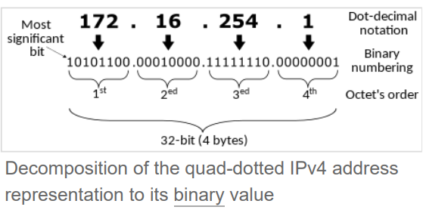

Most often addresses are represented in dot-decimal notation. Consisting of four octets of address expressed individually by decimal numbers and separated via periods.

CIDR notation: CLassless inter-domain routing. Based on variable length subnet masking (VLSM) is a compact representation of IP addresses and network mask.
- CIDR combines address with routing prefix. Followed by a slash with a count of leading consecutive 1 bits in the routing (subnet mask)

Other address representations were more used when classful networking was practice. Example is loopback address - where the two middle numbers were removed depending on network.

Allocation
OG design of IPv4 the IP address was divided into two parts
- Network identifier: most significant octet
- Host identifier: the rest of the address
  - Also called the rest field

Structure permitted 256 network identifiers which was too limiting. To expand the number, the network identifier was redesigned in 1981 to make network classes. The system would later be known as classful networking

–HIGHLIGHTED ON PAGE TRANSFER LATER

HTTPS vs VPN: why you need both
https://nordvpn.com/blog/https-vs-vpn/
VPN and HTTPS are capable of encrypting data.

VPN  - Virtual private network  - Encrypts more  - Encrypts all data passed through the VPN connection no matter the settings | HTTPS  - Hypertext Transfer Protocol Secure  - Only between browser and servers  - Only encrypts if enabled  - Most websites now support HTTPS  - Uses TLS encryption to secure data.

HTTPS and VPN are not competitors, both work to make the web safer. Alone there are gaps

HTTPS shortcomings

First access unencrypted
Sometimes the browser will first access an encrypted version of the website (HTTP) before being directed to the encrypted version. Creating an opening for a man-in-the-middle attack.
- The attacker could intercept the connection,redirect it to a malicious website. Once there, use phishing, malware injection or other attacks to cause damage.

Due to this risk website needs to implement HSTS as well as HTTP
- HSTS: HTTP strict transport security

To inform your browser to never load an unencrypted website. Meaning with HSTS, the browser only ever loads the HTTPS version of the site if available. ONLY 11% of top 1 mill websites use HSTS and only 2.3% preload.

A VPN solves this issue by encrypting all traffic from the get-go.

HTTPS can’t encrypt with single click
To be actually effective: all parties (browser, website and user) must do their part to uphold HTTPS.
- Browser - notify users when they enter an unencrypted website or block access to HTTP entirely.
- User - must notice and understand the difference
- Website- must implement TLS encryption properly + secure traffic between client and server.

For HTTPS to work it relies on websites and browsers to do their job, while the protocols give guidance on encrypting DNS requests - it is not guaranteed.

A VPN is a single service to do the job, making traffic between the user and destination online encrypted.

HTTPS can’t protect against phishing
Even with proper implementation, the website itself isn't necessarily safe. About 85% of phishing sites are now HTTPS websites. VPNS provide encrypted tunnels for data and offer other security features like notifying users if private data appears in data leak, filter out/ prevent malicious websites, some even scan for malware and prevent download.

End note
App creators are encouraged to secure data but can bypass the recommendations. Some take extra steps like certification pinning.

VPN is a mainstream security solution. Though changes are needed. Regular independent audits and VPN trust initiative is a starting point.

Back to Basics: Multi-factor Authorization?
MFA: Multi-factor authorization

Sometimes referred to as two-factor authentication (2FA), is a security enhancement that allows the user to present two pieces of credentials when logging into an account.

Credentials tend to be any of the three categories
- Something you know → Password, pin
- something you have → card
- Something you are → fingerprint

For 2FA the used information must come from 2 different categories.

One time codes or answering push notifications are good examples of a secondary authorization. Additionally some use the device you are on, as a credential (you logged in on your phone before so your phone is accepted as a secondary confirmation)

Overall MFA or 2FA adds another layer of security so a thief would need to steal two pieces of information at once without notice to be successful. Like your password and your phone.. Not likely to go unnoticed.

When to use MFA
Use whenever possible, specifically with sensitive data. Some organizations require it, many offer the option to.

What is Phishing
https://www.phishing.org/what-is-phishing

A cybercrime where the target is contacted by email, phone, text or dm by someone posing as a legitimate institution to lure the individuals into giving them sensitive information. The info is then useful in gaining access to important accounts and identity theft.

Also Voice phishing → vising and SMS phishing → smishing

First phishing lawsuit
- Filed in 2004 against california teenager
- Made a fake ‘America Online’ website
- Gained sensitive information including credit card numbers - withdrew money from them

Common features of phishing emails
Known as social engineering red flags, common features include..
They look too good to be true, have a Sense of urgency, include Hyperlinks and Attachments. Are from Unusual senders

Preventing Phishing
- Filter spam mail out. The filters assess the origin of the message and appearance of the message, though spam filters may block legitimate messages its a good first filter.
- Browser settings changed to prevent fake website opening. Usually browsers have a list of known bad websites, and show an alert if your attempt to access them
- Many websites use login info while showing an user image.. This set up is open to attacks. Should change passwords regularly.
- Websites should use CAPTCHA
  - CAPTCHA is the weird obscured messages a person must read.
  - Challenge-response test → since 1997
- Monitoring is used by banks, etc to prevent. The user can report phishing to them and they take legal action against the websites.
- Training for employees is helpful in prevention. As well check email links by hovering over them for a HTTPs → provided by SSL
  - SSL: secure socket layer certification
  - Eventually all sites will be required to have valid SSL

What is encryption?
https://www.cloudflare.com/learning/ssl/what-is-encryption/

Encryption is a way of securing data by scrambling the content via code - only authorized users know. It converts human read plain text into incomprehensible text (ciphertext) to move it then transfer back when wanted.
- Requires use of a cryptographic key
  - A set of mathematical values that the sender and receipt share so they can understand the encrypted message.

How it works
Mathematical process to alter data with an encryption algorithm and key. Plain text = “hello”. Ciphertext = “jgnnq221”

Encrypted data appears to be random but is produced logically in a predictable way - once you know the key. Allows for it to be converted back and forth easily. Can encrypt data when at rest (stored) or in transit (when transmitting)

Brute Force - is guessing at the answer
(here it would be guessing the key for the encryption)

Cryptography
A cryptographic key is a string of characters used in an encryption algorithm for altering data so it appears to be random. Like a physical key for conversion

Types of encryption
Two main kinds..
- systematic encryption
  - Only one key, all communicating parties use the same secret key

- asymmetric encryption
  - a public key encryption
  - Two keys, one private (decryption) and one public.
  - Foundational technology for TLS and SSL

Reasons for encryption
- Privacy: no one else reads communications/ data outside of the intended recipient. Stops hackers, ad networks, internet providers, gov from intercepting and reading data.

- Security: encryption prevents data breaches. Even if device is stolen, if encrypted properly the data will be safe

- Data integrity: avoids tampering with data in transit due to being unreadable.
  - Stops on-path attacks
    - Attackers place themselves between two devices - usually between browser and server - so they can intercept and modify communications.
      - Collect info, gain access, money, etc.
      - Steal cookies (for use in impersonating the victim online later)

- Regulations: many industries and govs, require companies that handle user data to keep the data encrypted. Examples of regulatory standards are : HIPAA, PCI-DSSm GDPR

Common Encryption Algorithms
- Symmetric
  - AES, 3-DES, SNOW
- Asymmetric
  - RSA, elliptic curve cryptography

Jail break encryption
Brute force attack is guessing the answer, to do it on encryption means millions or billions of guesses. Though brute force has increased speed with modern computers, modern encryption and strong passwords combined are resistant.

Additionally, HTTPS uses the encryption protocol TLS (transport layer security). In the past SSL (secure sockets layer) was standard but was replaced.

What is the CIA triad
https://www.f5.com/labs/learning-center/what-is-the-cia-triad

InfoSec → Information security
CIA → confidentiality, integrity, and availability

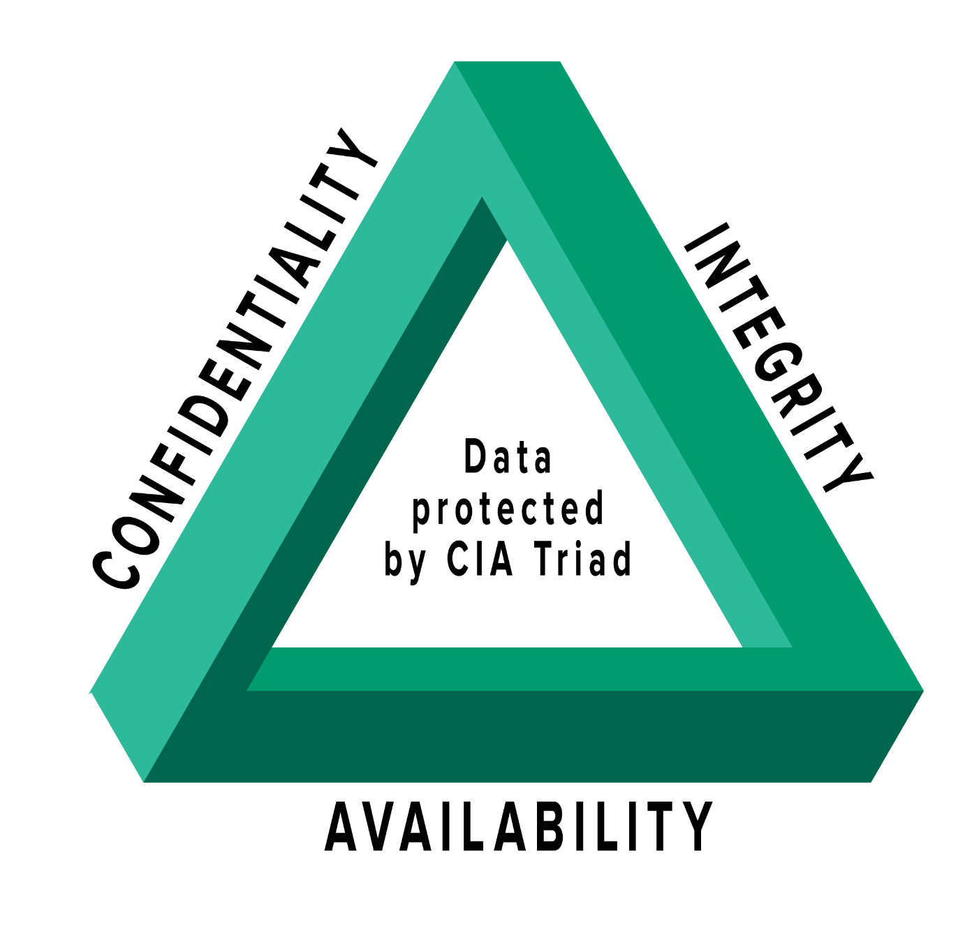
The three principles form the cornerstone of an organization's security infrastructure, acting as goals and objectives for every security program. When the CIA is off balance or one principle is violated - is when cyberattacks happen. It is the foundation of cybersecurity.

Security professionals evaluate threats and vulnerabilities based on potential impact they have on the three areas. They ask “would this impact the confidentiality, integrity or availability of the assets (being the data, applications and critical systems of the organization)

Confidentiality
Refers to efforts to keep data private, controlling access to unauthorized users. ex) payroll, ecommerce costumer’s card info, location, contacts.

Can be attacked directly by attackers or unintentionally through human error, carelessness, inadequate controls.
- Human errors could be bad password protection, sharing accounts, shoulder surfing, no encryption, theft of physical equipment.

Countermeasures options for confidentiality
- Data classification + labeling
- Strong access controls
- Authentication mechanisms
- Encryption (in progress, transit, storage)
- Steganography
  - Meaning a technique of hiding data within an ordinary, nonsecret file or message to avoid detection
- Remote wipe capability
- Proper education for everyone who can access the info

Integrity
Refers within infoSec to ensuring data has not been tampered with and thus can be trusted to be correct, authentic and reliable.

Ensuring integrity means protecting data in use, transit, and where its stored no matter the device or data center. Open to the same vulnerabilities of confidentiality.
- Direct compromised
  - Intrusion detection systems
  - Modify configuration files
  - Change system logs - avoid detection
- Unintentional
  - Careless, coding errors, bad policies, procedures or protection.

Counter measures include
- Encryption, hashing, digital signatures, digital certificates (CAs), intrusion detection systems, auditing, version control, strong authentication and access controls.

Integrity is key with non-repudiation: the inability to deny something. Helps each other

Availability
If its not accessible to authorized users when users need them - the application, data or system is of little importance. Availability means access when wanted, timely and reliable.

Hardware fails, software failure, power interruption, natural disasters, human errors and cyber attacks all jeopardize availability.

Countermeasures include:
- Redundancy (in servers, networks, applications, services.
- Hardware fault tolerance (servers and storage)
- Regular patching + system upgrades
- Backups and disaster recovery plans
- Denial of service protection plans

Applying the principles
Depending on the industry, security goals, business and regulatory requirements - one principle may be prioritized over another. Key here is prioritizing one means a trade off of the others. Its impossible to max out all three - there is always a tradeoff and a balance is usually needed.

Example of industry prioritization
- Financial - integrity
- Intelligence - confidentiality
- Healthcare - availability

OWASP TOP TEN
https://owasp.org/www-project-top-ten/

OWASP top ten is a standard awareness document for developers and web app security. Represents broad census about most critical security risks to web apps. Companies should look at list and work to minimize risks listed.

Off of 2021 security risks
- Broken access control
  - The 34 common weakness enumerations (CWEs) connected to broken access control were more prevalent in applications then other categories
- Cryptographic failures
  - Previously called sensitive data exposure
  - The renewed focus is on failures related to the root issue of cryptography that leads to sensitive data exposure
- Injection
  - 944% of applications had some form of injection. Cross-site scripting included
- Insecure Design
  - New as of 2021
  - Risks associated with design flaws. Need more threat modeling, secure design patterns, reference architectures
- Security Misconfiguration
  - 90% tested for some form
  - With more highly configurable software - not surprising the category increased.
  - Added XXE into category
- Vulnerabile and outdated components
  - Was called Using components with known vulnerabilities
  - #2 in top 10 community survey
  - No CWEs
- Identification and authentication failures
  - Previously broken authentication
  - Increasing availability of Standardized frameworks is helping
- Software and Data integrity failures
  - New as of 2021 - for assumptions about updates etc without verifying
- Security logging and monitoring failures
  - Failures in this category can directly impact visibility, incident alerting and forensics
- Server-side request forgery
  - Data says low incidence rate with good testing coverage
  - Include due to security community members saying it is - even without data to illustrate it rn.

CVE Vulnerability
https://www.imperva.com/learn/application-security/cve-cvss-vulnerability/

DDoS Attacks
https://www.imperva.com/learn/ddos/ddos-attacks/

DDoS = Distributed Denial of service attack
Meaning a malicious attempt to make online services unavailable to uses, usually from temporarily interrupting hosting server

DDos attacks are launched with a botnet ( numerous compromised devices, often distributed globally). Distinct from other DoS attacks fue to using a single internet-connected device to flood the target with traffic.
DoS and DDoS can be put into three types
- Volume based attacks

Prep Course

Get the most out of the bootcamp notes
Fast past, prepare early and often
- Two tricky skills at once
  - Core skills: dedicate most of your time to this one
  - First language: learn most of the language before hand

- Do not spin your tires
  - If your stuck do not wait for more than 15-20 minutes
  - Tight feedback loops
  - Ask to be guided to the answer not get the answer given to you
    - If you're behind and need a win it's okay to just get the answer occasionally.
- After you finish a challenge get a code review early and often
  - Don't just ask about your solution
  - Ask how the teacher would of approached it
  - Inquire about alternative solutions and the trade off between those solutions
  - After you solve a question - is the best time to better understand the solution and how it could be improved
- If ahead…
  - And really understanding everything so far ask the instructor for a harder challenge or a twist on an old one
- Be brutally honest with yourself
  - Pushing on is helpful but do not ignore gaps
  - Stop get help and learn it better before continuing
  - Delete the code and try again.
    - Test yourself for understanding
- Build relationships
  - Connections are critical and beneficial for all
  - Great advice for future training, employability and direction
  - Both with teachers and classmates

Community-based learning
Designed to mimic a junior cyber security team. The stronger the connections the better everyone learns meaning that everyone will succeed better and provide a greater network then alternatives. A strong cyber security team is just that a team - collaborative skills and supportive elevating approach is essential for knowledge to grow

Being a resourceful problem solver
Detectives are resourceful, problem solving individuals also have different techniques to apply to come up with the solution. Not discouraged easily. Eager to tackle new challenges.

Patience
A Lot of intentional thought, effort and resources are combined for the learning material. The camp is inherently challenging but know there's a method to the madness. Rarely does a day go as planned - hurdles and adjustments to objectives are common and often frustrating or limiting but being part of a cyber security team is handling the unexpected.

Avoid…
- Isolation
  - Need mentors to help guide, course correct and save time. Mentors are around for help, networking, real world advice and guidance within and outside of the course
  - If stressed: check in. ask if efforts are going to the right areas, see if you are doing it right.
  - Reach out to…. https://www.lighthouselabs.ca/team
  - Developing skills to reach out when something is hard even if “you should know it” is key to seeking out mentorship and overcoming concerns
- Memorizing
  - Don't focus on perfectionism and memorization.
  - Continuous hands-ons practice and muscle memory via doing is ideal
  - As a dev you have the internet to check for little mistakes. If doubting where to reiterate the problem - check in
- Imposters syndrome
  - Comparing yourself to others is often a debilitating setback.
  - Imposter syndrome: the belief you are a fraud and don't deserve to be here
  - Focus on your daily/weekly/ monthly improvement instead
  - One step at a time - strive to be better today then you were yesterday

Course details
- Readings, tasks and exercises. There will be knowledge checks and quizzes. Meant to provide feedback to the user on what concepts need to be sharpened. The knowledge checks and quizzes are not graded and for self evaluation only
- Review the results even if it's perfect score - great opportunity for reinforcement

- At times in the course - will be invited to reflect on ideas and consider your own areas of interest or explore areas in depth. - personally evaluate the use of this.. Remember you can always come back to the content
- Google - new bestie, give a search some context and try to specific cyber security
- To prepare try being at the computer for 10 hours doing the prep work

Videos
- Multimodal learning aka see the information in more then one format. External links, videos, reading etc.

Support Resources
- Discord prep form
- Larry AI Bot
- Peers
- Learning Advisor

Intro to Cyber Security
Key Governing bodies in North America
- Canadian Center for Cyber Security
  - Protection of digital information and the integrity of the infrastructure and transmitting digital information. Specifically, cyber security includes the body of technologies, processes, practices, response and mitigation measures designed to protect networks, computers, programs and data from attacks, damage or unauthorized access as to ensure confidentiality, integrity, availability

- National Institute of Standards and Technology (NIST)
  - Series of steps to prevent or manage risk of damage to unauthorized use, exploitation and if needed restore electronic information and communications systems and information contained to strengthen the confidentiality, integrity amd availability

Effective cyber security depends on the people who detect, monitor, minimize threats or harms to the information systems of the organization.
video “Introduction to Cybersecurity”

Brief history of Cyber Security
Brief history: traced back to the 1960’s when phone phreaks would use a series of beeps to trick telephones into letting them make long distance call for free. Additionally 1971, with the creation of Creeper (the first computer worm) and Reaper (software chased it down and removed it).

- First wireless hack in 1903 Read the Story

- Read more about the history of hacking and Cyber Security: The History of Cybersecurity and A Brief and Incomplete History of Cybersecurity

Modern Day
Gone are the days of simple, mostly harmless creepers and reapers. Cyber attacks are consistently growing in scale, sophistication and reach. Attacks are big business and results are harmful and destructive.

Cyber security varies widely in roles, procedures, threat detection to incident response. Recent changes in interactions with technology - working remotely, cloud based content and company servers. The change in technology use, offers a new level of challenge to maintain a company’s cyber security.

As technology grows so does the need for cyber security to keep up.

Role of cybersecurity
Personal
Involves protecting personal devices and data from vulnerability. To do this on an individual level by protecting devices with security software, limiting identifiable information (PII) both on it and on socials.
- PII includes seemingly minor information - like mailing address and birthdates.

Organizational
Organizations that handle PII of users also need to protect information from unauthorized access. Additionally consider the possible access to trade secrets or confidential financial information by attackers.

National Security
Governments protect information that could affect national security - aka military info, infrastructure, gov decision making processes, PII of citizens.

Fundamental principles of Cybersecurity
- Vulnerability: any part of the system that could be exploited or attacked. Examples) outdated software, weak passwords
- Threat: the potential to exploit or use the systems’ vulnerability to harm, damage or disrupt the organization. ex) viruses and malware
- Attack: when a person or organization maliciously attempts to exploit a vulnerability. Purpose of attack is to destroy, disrupt or access a system or information. ex) copied ID badge, installed malware.

CIA triad - reiterated ____________________
- Confidentiality: ensuring only authorized users can access data
- Integrity: making data reliable and trustworthy
- Availability: data is accessible to authorized user
The CIA Triad is fundamental in modeling secure information

Incident response - how cyber security team addresses an issue of security via policies and processes. Includes malicious, accidental or unexpected events

Risk management - process of assessing, identifying, mitigating and monitoring info and security risks for an organization. Is an ongoing process - non singular action

Governance + compliance
Key responsibility of cyber security team to ensure that the organization is complying with regulatory or gov requirements

In Canada

PIPEDA
  - Personal information and electronic documents act
  - Aims to protect personal info when used for commercial purposes, includes obtaining consent, only use the information for the purpose specified
https://www.priv.gc.ca/en/privacy-topics/privacy-laws-in-canada/the-personal-information-protection-and-electronic-documents-act-pipeda/pipeda_brief/
- Sets ground rules for private-sector organizations collect, use and disclose personal information, for non-profit and commercial activities across Canada
- also applies to federal-regulated employees personal info
- Key responsibilities
- Accountability
- Identifying purposes
- Consent
- Limiting collection
- Limiting use, disclosure, and retention
- Accuracy
- Safeguards
- Openness
- Individual access
- Challenging compliance
- The act applies to private-sector organizations in the course of commercial activity. Alberta, British Columbia and Quebec have their own private-sector privacy laws. If the provincial laws are substantially similar to the federal - the organization tends to be exempt from PIPEDA.
  - Unless they cross borders provincial or national
  - Ontario, NB, NS, Newfoundland and Labrador also have substantially similar legislation.
- Federally regulated organizations
  - airports, aircraft and airlines
  - banks and authorized foreign banks
  - inter-provincial or international transportation companies
  - telecommunications companies
  - offshore drilling operations
  - radio and television broadcasters

Personal information under PIPEDA
Age, name, ID numbers, income, ethnicity, blood type, opinions, evaluations, comments, social status, disciplinary actions, employee files, credit report, loan records, medical records, disputes between consumer/merchant, intention

What is not covered by PIPEDA
Personal info handled by the federal government, provincial or territorial govs and their agents. Business contact information (employee names, title, business address, telephone num, email) collected solely for employment/ profession relations. Greeting card lists for personal purposes. Or collected information for journalistic, artistic or literary purposes
- Charity groups and political parties and their associations

Digital privacy act
  - Amendment to PIPEDA - 2015
  - Companies required to report significant data breaches. Make sure customers are aware of the compromised info
_____________________________________________________________

PCI DSS
  - Payment Card Industry Data Standards
  - Protect payment data, standards include a set of controls and processes to protect your card data where its kept or processed
PCI-DSS Resources

_____________________________________________________________

OFSI
  - Cyber Security Self-Assessment from the Office of the Superintendent of Financial Institutions
  - Financial institutions are also required to comply with PIPEDA in handling of the information privacy
  - OFSI released a cyber security self-assessment tool, help FRFI ensure meeting up-to-date requirement and standards
    - FRFI - federally regulated financial institutions
Cyber Security Self-Assessment from the OFSI
- Meant to help FRFI prepare and improve
- Rating levels: intended to estimate the maturity of that control
  - 1 to 5 with level 0 for lack of any progress with respect to the control
  - There tend to be interdependencies
Levels
- 0: Non-existent. Identified control has not been implemented/ discussed or understood within the organization
- 1 : Initial. Controls at this level are usually undocumented and state of dynamic change. Being considered or implemented in a reactive manner by individual personnel or events.
  - Risk assessments done in a rushed or haphazard manner
  - Level 1 organizations implement security systems and services unequally apply with gaps of coverage that may miss deadlines or go over budget
- 2: Repeatable. Implements control in a repeatable manner across different systems and environments with consistent results. While also documenting, applying requirements and structured processes that are common practice.
  - Additionally there may not be suitable documentation explaining implemented controls, how to use or the understanding may be limited to specific individuals. Thus a potential challenge of accessing information if those individuals are unavailable.
- 3: Defined. Controls are well defined, understood and documented description (could include policies, standards, procedures, configurations so it can be explained and consistently applied).
  - Controls subject to some degree of improvement over time
  - reviewed / managed proactivity with some understanding as to inter-dependencies. Could be considered a developmental stage with the organization demonstrating commitment to cyber security.
- 4: Quantitatively Managed. Organization sers quantitative objections for control effectiveness, performance, quality and gathers metrics to use in planning. Largely linked to the business, operational and security requirements.
  - As metrics are gathered/analyzed the organization can define normal operating patterns and predict control performance.
  - Controls are monitored to check if they operate within defined parameters. If not the personnel can be alerted and take action
- 5: Continuous Improvement. Organization continually improves control - done incremental and innovative technological improvements, refinement and continuous education.
  - Organization may be agile, adaptable and open to opportunities. Where security and risk management has become part of the culture with team collaboration and best practices.

_____________________________________________________________

ICSs
  - Industrial Control Systems Cyber Security regulations
  - ICSs control critical utilities/ public infrastructure. Canada gov provides guidance on making sure ICS is secure and following the NIST guidelines
Security considerations for industrial control systems

The ICS automates and controls industrial processes and mechanical functions to keep processes and machinery running smoothly. Supports critical infrastructure that is key to ongoing safety, security amd well-being of Canadians.

Base controller for other layers of infrastructure, therefore should be secured to maintain functionality.

What is an ICS
Includes control systems like distributed control systems, supervisory and data acquisition systems. The system can be fully automated or not, simple or complex. Traditional ICS was not interconnected and was isolate/ secured physically - which left it vulnerable

Main threats
ICS is a high-value target due to real world effects, from minor to life threatening. Target attacks directly compromise an organization or spread malicious software to breach systems.
- Ransomware
  - Threat actor delivers malware through an entry point to restrict all functions from being accessed until a ransom is paid
- Insider Threat
  - Anyone with access to the ICS can cause harm to the system
- Denial of Service Attacks
  - Attack makes the service unavailable for intended users. Can delay functions and operations causing the organization to use more resources to restore operations
- Vulnerabilities to be aware of
  - If ICS is not properly configured or connected to an unpatched virtual private network, more vulnerabilities.
  - If remote connections - should be handled cautiously.

Risks
When ICS is compromised your organization can be at risk of blocked/ delayed information flow, unauthorized changes that could damage equipment, inaccurate information sent to operators, infected ICS software can spread through the company. This all can cause malfunctions in operations and lead to loss of profits, data or harm to reputations.
Secure ICS by
- Isolating the system from regular corporate functions or to different network so that can disconnect from the internet without disrupting other activities
- Manage access or privileges - limit who can access it and consider non-remote access only. (if remote have MFA, encryption and restrict access to sensitive data)
- Train employees on the risks and why security measures are in place
- Log and monitor all access and event information. So if the system malfunctions or is attacked so the logs can capture the information. (like a backup - what was changed)
- Security software and hardware, scan all removable media before connection and use VPN or private browser to protect privacy
- Update and replace systems to fix vulnerabilities and maintain ongoing functionality.

Cyber security is an ever changing field, with every advancement comes a new set of threats.

Types of Cyber Attacks

APT | Advanced persistent threat | Combines a variety of different approaches over a period of time to access the same system/ network. Involves renewed attacks to adjust for defensive security and multiple attacks over time
DDoS | Distributed denial of Service | Bombarding a server/ network with traffic from many sources to disrupt operations of services or network activities
IoT | Internet of Things Attack | Accessing a network though everyday objects connected via a network which tends to have less robust security setups. (smart watch or camera)
 | Malware Attack | Introducing secret program into a system that damages, destroys or compromises data within that system
MITM | Man in the Middle | Intercepting or altering data in transit between two legitimate points of communication
 | Phishing | Fraudulent practice of sending emails purporting to be from reputable companies in order to induce individuals to reveal personal information.
 | Social Engineering | Tricking someone into sharing sensitive information by establishing trust and a relationship
 | Zero-Day Exploit | Using a previously unknown vulnerability in software or hardware to gain access to a system or sensitive information

Methods for carrying out attacks
- Simple to complex : phishing is simple while APT is long term and pre planned attacks used by high skill individuals.
  - Read the report from PwC UK (pages 4-14 outline how the attack happened)
  - Watch the conference presentation of the report
- In person or remote
- Broad spectrum or targeted
- Us vs Them

Why do we need Cyber Security
Effects of cyber attacks can do..
- physical / digital harm: theft, damage, exposure off information
- Economics harm: disruption of operations, negative stock prices, incurred fines, ransoms
- Psychological harm: confusion, anxiety, shame felt
- Reputational harm: lost customer trust, bad press, loss of staff, revoked accreditation
- Social harm: negative public perception, organizational morale decline

Read the full article “A taxonomy of cyber-harms: Defining the impacts of cyber-attacks and understanding how they propagate”. Focus especially on tables 1-5 on pages 9-10.

Protect Against Cyber Attacks
Strong Passwords - common best practices
- Minimum length - longer than eight characters
- Both upper and lower case letters
- One or more special characters
- One or more numbers
- Automated periodic change of passwords

Multi-factor authentication
Up to Date systems
Understanding laws and reg.
- Geography
- Sensitivity of information
- Personal data
- Vulnerable populations
- Ethical considerations

Frameworks
Series of steps/ areas of consideration to guide cyber security policies, methods, processes. Applying a framework provides clear, understandable roadmaps for plan designs, shared industry standards, comprehensive set of recommendations.

Variety of frameworks to choose from. Most encountered frameworks for entry-level positions include…
- NIST cybersecurity Framework
- MITRE ATT&CK Framework

SOC: Security Operations Center
According to IBM an SOC is an in-house or outsourced team of IT professionals to monitor infrastructure, to detect cybersecurity events in real time.
Read about SOC common and best practices from the SANS Institute

Human factors are key in cyber security practice, vulnerabilities can be found by gut feelings or simply by asking a question.

Computers and Operating Systems

Brief History of Computers
- Abacus: chinese origin, fifth century BC, for complex algebraic operations
  - first computer
- Slide Rule: scottish (John Napier), 17th century, analog counting for logarithm calculator
- Loom: first programmable mechanical machine, 1801 by french (Joseph-marie Jacquard). Capable of controlling the making of fabrics through perforated cards

- Binary: made by french mathematician Pascal, first automatic calculating machine.1640
- Calculator: german Gottfried Wilhelm Leibniz, first modern binary numbering system. “Leibniz Wheel”
- Boolean searches: George Boole, one of the founding math boolean logic.

Four Periods of Computing
- First Generation (1940 -1959)
  - Worked through electronic circuits and tubes. Restricted use. ENIAC consumed 200 kilowatts and had 19k valves
- Second Generation (1959 - 1965)
  - Immense, worked through transistors to replace the bigger valves. Commercial use began
- Third Generation (1965 - 1975)
  - Worked by integrated circuits, these replaced transistors and allowed smaller dimensions and greater capacity. Chips were create and personal computers began
- Fourth Generation (1975 - present)
  - Computers decreased in size, increased speed and capacity. Microprocessors with lower energy consumptions. Personal computers use and capability has significantly increased in 1990.
  - Additionally, integrated software appeared and handheld computers emerged in the lead over time.
- Fifth Generation?
  - Supercomputers used by massive companies like NASA suggest a fifth generation of computers may have occurred. Within this generation would be multimedia technology, robotics and the internet.

Kinda know already - Get to Know Your Computer
Hardware
Set of parts built around the computer's microprocessor, each part a different function but together allow varied activities. Physical and tangible components. “Brick and mortar”
Examples
- Input: keyboard, mouse
- output : printer, monitor
- Secondary storage : hard drive, SSD
- Internal components: CPU, motherboard, RAM

Software
Uses codes and languages to allow user to interface and request tasks

System Software - allow user interaction with the machine (OS)
Application software - facilitate the performance of tasks (text editors, spreadsheets, browsers

Main Components things

- Cabinet - the metal “box” - function is to keep each part in its place.
- Central Processing Unit (CPU) -computer's main processor/ machine's brain. CPU determines how fast the machine operates
- Cooler - high temperatures affect the computer's performance, so the cooler controls and maintains the temperature. The main cooler is attached to the CPU, more specifically on the central area of the motherboard. Other coolers like fans exist too
- Processor - works with the information generated during the computer's operation, processing each activated function.
- Optical drive - allows optical media (CD, DVD or Blu Ray) to be read and reproduced on the computer.
- Hard Drive (HD or HDD) - the hard disk is responsible for storage of files and operating system data. It can record and rewrite information. Without a hard drive, a computer would have no space to install the system or save files.
- Solid-State Drive (SSD) - an evolved type of HD that is faster, smaller and quieter then a hard drive and more durable against physical damage.
- Random Access Memory (RAM) - the fast access memory that temporarily stores information that needs to be accessed quickly by the operating system, which includes files from the system itself. The information stored in RAM is lost when the computer is turned off or briefly loses power.
- Read-only memory (ROM) - A permanent type of memory storage used by the computer for important data that does not change.
- Basic input/output system (BIOS): A type of ROM used by the computer to establish basic communication when the computer is started.
- Cache - The storage area for frequently used data in extremely fast RAM connected directly to the CPU.
- Virtual memory - Space on the hard disk where data in RAM is stored temporarily, when necessary.
- Motherboard - The computer's main board interconnects all other components to make the machine work. It allows interconnection between RAM, processor, HD, video card, optical drive, etc. This work is done by controllers responsible for communicating between the devices and slots each fits
- Power supply - An electrical transformer takes power from outside the machine and modifies it to distribute it to machine components. It is responsible for feeding the computer components with voltages of 3.3, 5 and 12 volts, as needed

- Operating system - Basic software that allows the user to interface with the computer.
- Integrated Drive Electronics controller (IDE) - primary interface to the hard disk, CD-ROM and floppy disk drive. (This device is largely obsolete, but you may still run into it from time to time).
- Peripheral Component Interconnect (PCI) Bus - The most common way to connect additional components to your computer, PCI uses a series of slots on the motherboard into which PCI cards plug and external ports for devices, such as a printer, scanner, monitor and many others.
- Small Computer System Interface (SCSI) - This method adds extra devices to the computer, such as hard drives or scanners.
- Accelerated Graphics Port (AGP) - a fast connection the graphics card uses to interface with the computer.
- Sound card - To record and play audio, converting analog sound into digital information and vice versa.
- Video card - processes files on the computer for display through the monitor. What you see on your computer screen are graphics generated by the video card.

Introduction to Operating Systems
Consider the OS as the conductor of an orchestra, following written instructions that guide the system. The conductor is central in control of various pieces to get the desired output of music. If every part or musician works correctly according to the conductor it will become a lovely concert

In short - OS is the overall program to interpret user inputs and activates the output devices to finish the request

Origins
- Early OS only ran on the machine installed, no other. Very expensive so never sat idle
- Csc scientists began automating the change overs for speed
  - Time logs, cost accounts and specific schedule of programs to run were automated shortly after.
- As tasks became common so did the physical tools and programs needed to run them
- The increased familiarity lead to more programs being written and a collection of ideas began - accessible to other programs
- In 1970s and 1980s, computers did a massive shift
  - Computers became exponentially stronger, powerful and cheaper. Becoming accessible to the average joe.
  - GUIs appeared and icons on screen
  - The OS generation began looking closer to today's versions

Three OS dominate Personal computing today
- Windows - 75% market share
- MacOS - 15% market
- Linux - small but dedicated growing base

Windows is based on the idea that whatever hardware you want to use pays for it and Microsoft will support it. Windows makes cash by licensing their software so operating on as many systems as possible is ideal.

MacOS is Apple and they sell software and hardware. Focusing on the user and delivering a fluid, seamless and satisfying experience as they control what machines the OS will run on. Apple machines tend to be expensive, more secure but incompatible with non-apple devices and hardware

Linux is Open Source, the code is free to copy, use, modify and distribute. Linux appeals mainly to tech savvy people who want to get involved in nuts and bolts of the machine - to optimize for specific needs.

Components of OS
For security operating systems have two components
- Kernel - code that directly acts on the system components, organizing allocation of memory and resources
- Shell - acts as an interface between user programs and the kernel

Kernel
The kernel receives requests from application processes to use system resources for their task. It initiates a process, a “wrapper” for that request that allocates resources and instructs on how to start. When the task is accomplished, the kernel terminates the process and reclaims resources.

The kernel is stored in protected memory and normally cannot be accessed by user programs. Communicating with the environment vis interrupts - which are pauses in the operations to indicate an event

Software interrupt is a message to process an event, may be expected or errors. If expected, the CPU will absorb new information and alter the process to accommodate the new information. Other events are error conditions (like improperly constructed instructions) where the request cannot be done. Usually small errors like invalid memory address or divide by zero.

Signals are generated by a process when certain events happen.
- Process finishes normally, or error exception\
- Process runs out of resources
- Executes an illegal instruction
- Sets an alarm event
- Aborted from keyboard
- Process has a tracing alert for debugging

Hardware interrupts are messages to the CPU that the task was completed. Hardware devices are slower then CPU so rather than system wait for the hardware to execute, the CPU hands off instruction to the Hardware with expectation it will return once done. Interrupt is confirmation

User interface is for the user to give instructions and communicate requests to the OS, and for results to be displayed.

OS Modes:
OS have minimum two modes, User and supervisor mode. Supervisor offers unrestricted access to resources and is reserved for background, low-level processes that are tightly controlled by the OS. While user mode blocks direct access to the system resources and requires all requests be routed through the kernel - thus used for most non-core functions

OS Network:
The OS is responsible for handling multitasking of the system as users usually want to do. AS with networking, the most important job in the internet age. To successfully connect to and from the internet. The OS uses a series of internationally standardized protocols to communicate with other machines over local and web, different protocols for different tasks.

OS Security:
OS is key in protecting the integrity of access to the system resources. To do so the OS will have rules in place to see if a request for services is authentic and internal security to protect itself from external threats (with firewalls). To prevent access except for explicitly allowed and controlled.

Ports and Hardware Security
A computer port is a hardware or logical software point where data can be transferred from a device external to the processor and vice versa.
The prep focuses on the most common and current ports

Ports are key connections to a computer, hardware is the foundation of digital trust. As the world moves more towards modern electronics with cheaper, faster, stronger chips and rise of AI, IoT and autonomous systems - a compromised physical component could destroy cybersecurity layers

Hardware-Based Attacks: A quiet threat
Typical cyberattacks that make headlines are large companies victim to software based attacks from infamous cybercrime syndicates. However attacks that don't make headlines are still attacks and problems. Cybersecurity teams often focus more on hardware based security due to the vital role hardware plays.

Myths + Facts of Hardware Security
- Hardware based attacks are uncommon - false
  - They are often withheld information around hardware based attacks as they reflect insufficient physical security
- Hardware-based attacks are quickly identified - False
  - When a company is breached - the public assumes it was phishing or software. Easier for companies to ignore the rumors and go with it.
- They are localized and small impact - False
  - They can have a wide reach. Consider ATMs - connecting to a port and using a black box to trick the ATM into releasing cash

Get to know your Port
Port USB 2.0
- Most common usb port, day to day
- Variou devices can connect through it
- Most versatile and used even after the USB 3.0 arrived

USB 2.0 w auto-instal of BIOS
- Found in some motherboards produced by ASUS
- In theory able to automate the machines BIOS install and update
- Used by copying a utility onto a pen drive and connecting it to this port.
- Press the button next to the usb port and the BIOS will be installed as soon as the PC is turned on.
  - A niche feature for more advanced users
  - Helps with severe overclock or other modifications that prevent a normal machine boot

Red USB 2.0
- Same as usb 2.0 but extra power
- Found on motherboards by ASUS, gigabyte and other manufacturers.
- In response to IPADs and other devices needing more current then regular USB 2.0 ports can supply

USB 3.0
- The blue port and newest version of USB
- Superspeed USB
- Capable of transferring data up to 5 gigabits per second / 625 MB
- Compatible with usb 2.0 devices but can limit speed
- Need new cord for full effect

eSATA
- High-speed external drive - key to video and Raw imagery
- Created to provide a faster alternative to USB 2.0
- Only used in storage devices
- Some laptops have a hybrid USB connector

Ethernet Port
- For network
- RJ45 Ethernet network Connection - most obvious network connection
- Three times faster than wireless connection
- Ideal for transferring large amounts of data

Sound/audio Ports
- Audio Analogue Ports
  - Most used and color-coded
- S/PDIF digital audio
  - Some pcs output digital audio
  - Uses a fibre optic cable and specifically toshiba

VGA: video output
- Video Graphics Array
- Integrated graphics have VGA ports
- Most monitors on market

DVI: first digital video ports
- Digital visual interface
- Arrived in 1999
- First widely used digital connection
- Was left to history due to displayPort and HDMI

Displayport
- Multiple monitors using one Port
- May seem redundant given HDMI ports
  - Display port is licensed by VESA and does not require pay royalties
  - In display port 1.2 - can chain up two monitors with high bandwidth
  - Hubs to connect even more monitors
- Up to bandwidth of 49 megabits per second

Apple Mini Display port
- Variant of displayport with smaller connector.
- Common on video cards in 6000 and 7000 series

HDMI: high definition video output
- Standard
- High definition tvs, pc, tablets
- 1.4a ha bandwidth for 1080 p res and 120 fps
- Able to carry audio signal as well

Mini HDMI
- On digital cameras

Legacy ports
- PS/2
  - For a mouse or keyboard
  - Most motherboards have these ports
  - Mouse to the green, keyboard to the purple
- Firewire: used for digital video
  - IEEE 1394
  - Very common with camcorder and first gen ipods
- Paralela
  - Parallel printer port
  - For printers
  - Needed for POS and receipt printers
- Serial
  - For sensors and instrumentalization
  - 9 pin D shaped connector
  - Pos, remote sensors and laboratory instruments

Vulnerabilities and Risks of Buttons and Ports
USB drives are easily used at home and office, leds to security risk of spreading infection
People rarely think twice before connecting USBs and other foreign medias to a network or system

Access to the internet can spell trouble, easy and effective protection is to never connect even to a local network. This security is often only for extremely valuable information and critical processes. This is known as an air gap

Remote and isolated devices can still be targeted via the following

Thunderbolt ports
- Research at Eindhoven University of Technology in the Netherlands, hackers can access drive content via thunderbolt ports in minutes.
- Only affects computers manufactured before 2019
- only exploitable via physical access
- Using Thunderspy, it is possible to steal data from a laptop that's locked, password protected and encrypted hard drive.
- Not the first issue with thunderbolt ports, common issue with high speed direct access to transfer data directly to memory
    - Links.. Thunderbolt Flaws Expose Millions of PCs to Hands-On Hacking, Breaking Thunderbolt Protocol Security: Vulnerability Report, Thunderspy
USB ports
- USBs can be infected by invisible layer, undetectable by antivirus software
- No technical solution to the problem
- Experts have made software BadUSB - which can be installed on usb firmware
- Layer is responsible for devices essential functions and cannot be scanned by security
- So even if infected and formatted, the thumbdrive poses a risks
- Legendary Stuxnet attack began via an infected usb
    - Links…Every USB Device Under Threat. New Hack is Undetectable and Unfixable, An Unprecedented Look at Stuxnet, the World's First Digital Weapon

Complex Hardware Vulnerabilities
Computers never connected to the network still have heat, magnetic fields and noise. Which can be used to extract information with inventiveness and physics

Though most noises made by computers are outside of human hearing ranges, it is possible for an infected computer to adjust noises it makes to share information across short distances. As computers use for example ultrasound to activate wireless speakers - which could be manipulated so a receiver nearby could pick up information though coded noises.

the AirHopper
Same can be true for electromagnetic fields created by computers. Another method is GSM frequencies encoded and emitted by the memory bus to be picked up by a cellphone operating on the same frequency.

A simple fix to electromagnetic radiation is a Faraday Cage, a constructed device that blocks all electromagnetic signals. However the cage doesn't block all magnetic signals.
- Cellphone wont work in the faraday cage but a compass will.
- High frequencies generated from CPU will pass though the cage if a receiver is close enough to the cage

Additionally lights and optics can be hijacked to convey information. There are real life cases of hackers using LED indicators to steal and transmit data. Cases to look up..
- LED-it-GO
- xLED
- AIR-Jumper

All computers generate heat which was manipulated to transmit information in BitWhisper

Lastly, vibrations can be detected such as changing fan speeds in a computer to detect changes that can be picked up by your phone laying on the same table

Securing Buttons and Ports
Device control: a company allows only recognized devices to be used in the company systems, adding encryption.
- With device control, data is only copied with proper encryption key
- Only be accessed with proper encryption key
- Making it impossible to open the data outside of recognized equipment
- Device control allows admin to block completely and audit copied files, etc

Restricting removable media
- Works by priority
  - Full access: setting with higher processing priority - all or some register media is unrestricted so user can read, write, edit, transfer
  - Read only: medium priority. If read only, removable media without full access settings will be only readable. User can view what is inside but not edit or transfer
  - Total Blocking: low priority, blocking media that was not fully accessible or read only. Cannot access media content with configuration.
- Exceptions are possible based on the serial number and domain controller

Securing Ports: Imperative to control each port, to control data leakage.

Audit: all media have full access and can be audited. All content copied can have file name recorded or copy, allowing admin access to content.
- Even if the user takes a laptop or other device home it can be audited.

Tips to secure include
isolating the machine, preventing contact with infected media, creating air gaps, placing them inside faraday cages, and filling air gaps with white noise to mask transmissibility by sound. Limit or disable infrared functionality, tape over LEDs, Install and configure security software and updates.

What is Binary?
Bi as in 0 and 1

1945
1 ( x10³) + 9 ( x10²) + 4 ( x101) + 5 ( x100)

1 + 8 + 16 + 128 + 256 + 512 + 1024 = 1,945 (decimal)
Aka 11110011001

Calculating
1 x2^0 = 1x1 = 1
0 x2^1 = 0x2 = 0
0 x2^2 = 0x2x2 = 0
1 x2^3 = 1x2x2x2 = 8
1 x2^4 = 1x2x2x2x2 = 16
0 x2^5 = 0x2x2x2x2x2 = 0
0 x2^6 = 0x2x2x2x2x2x2 = 0
1 x2^7 = 1x2x2x2x2x2x2x2 = 128
1 x2^8 = 1x2x2x2x2x2x2x2x2 = 256
1 x2^9 = 1x2x2x2x2x2x2x2x2x2 = 512
1 x2^10 = 1x2x2x2x2x2x2x2x2x2x2 = 1024

Bits and bytes
Semiconductors have a threshold for voltage, anything over it gets passed along - if below gets blocked. Circuit reads current as 1 and no current as 0

Smallest value is called bits. Bit either 0 or 1
To differentiate between long strings of numbers and large numbers, the computer organizes the blocks into bytes.

A byte is eight consecutive bits of data. Ranging from 0000 0000 to 1111 1111.

ASCII == American Standard Code for Information Interchange
The first 32 numbers in this table do not represent characters. The first 32 represent now obsolete commands.
Other charts were developed to interpret values from 0 to 127 in different ways for user needs.

~~~~~~~~~~~~~~~~~~~~ On (1) and Off (0). Paper holes (1) and didn't (0). Tapes were magnetized (1) and demagnetized (0). Now SSD use Semiconductors to act as switches.

What is Hexadecimal?
0 to 9 and then 10 = a in abc order till 15 = f

So… 16^0 = 1, 16^1 = 16, 16^2 = 32, 16^3 = x …. Etc

1945 turned into hex is … 997

16^0 * __9_
16^1 * __9_
16^2 * __7_
https://www.rapidtables.com/convert/number/decimal-to-hex.html

Why it matters in cyber attacks
Hackers use hexadeciminal to encode malicious requests as most filters and users do not look for it. It is a low effort method to mask intentions and increases efficiency of head on attacks.

Double encoding
Double encoding involves encoding data twice through the same process, this is useful in bypassing security filters.

Security filters will decode once but the second decoding will happen in the backend, which is lacking proper security to check for such requests

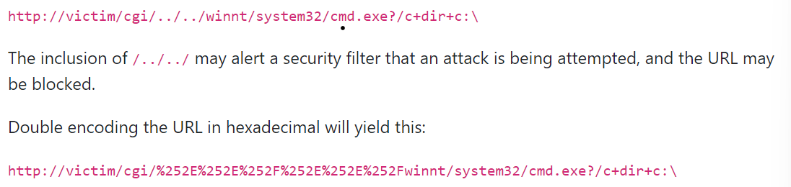

Hexadecimal IP address
IP addresses have several formats including hex format, which is readable by web services but does not look suspicious to the user or security filters. Often used with spam emails.

A dotted format would be caught by the filters and domain by users or the filters. But hexadecimal Ip addresses tend to get though

Overall hexadecimal is useful in understanding encryption algorithms and forensic tools.

Intro to Networks
Networking and cybersecurity are closely related and effective network security is needed for security and reliability of communication. To be a security professional is to understand the principles of networks due to there core position of modern information systems.

Fundamentals of networking
Computer network is formed by a series of connections and the internet is the only one that covers the world

The connection allows exchange of information between different devices. From file sending to texting to online games and social media. For the connection to occur its necessary for devices and sites to follow protocols. Most importantly is TCP/ IP.

Crash Course on Computer Networks - get key terms

How does communication and network work?
Working as a grid or mesh that connects systems, these interconnected devices ate known as nodes. For the network to function properly standardized norms must be enforced, thus protocols come in. To make sure data is verified and validated properly.

Networks also provide virtual services, essential info for various segments, and resources. They can transmit data though cables, wires and airwaves.

Different types and how to use
Personal Area Network (PAN)
PAN is restricted to domestic areas and consists of connected devices all owned or used by the same person. Usually a single person is a PAN and a home is a LAN

Local Area Network (LAN)
Formed by devices in the same physical area, small spaces that do not have high external contact demands. Usually homes, office, or schools.

Metropolitan Area Network (MAN)
MAN is like LAN but larger space. Connects between units or buildings in the same city.

Wide Area Network (WAN)
More extensive network and covering from a country to a continent as needed.
- The Internet is a WAN

Wireless LAN (WLAN) - same as LAN but wireless

Wireless MAN (WMAN)
Is a MAN but connected wirelessly though cell towers to join companies, universities or gov agencies.

Wireless WAN (WWAN)
Same as WAN but wireless. Used by mobile connections like 3G, 4G, 5G. Allows integration of several users in the wifi model at once.

Virtual Private Network (VPN)
Connection between computers made privately. High privacy and network security in data exchanges, critical in prevention of cybercrimes.

Software-defined WAN (SD- WAN)
Creates a virtual network ovary over physical infrastructure of enterprise WAN

Network Components
Amount of components used to make up a computer network depends on the purpose of the system, desired features, and level of security required.

- Servers: hold shared files, programs and OS, providing access to network resources to all users on the network. Sometimes a server is referred to as a host computer.

- Clients: are computers that access and use the network, aka users. Who request and receive serves from the servers, often a personal computer

- Network interfaces: every device has one. NICs are either integrated into the motherboard or separate, they take information from the computer and send it over the network.

- Hubs (Concentrators): when multiple computers are on a network, they communicate with a central hub. The hub moves network signals around and decides if information received is for it or not (discarding if not).
  - If a primary hub then the primary broadcasts signal from the primary computer to the others.

- Bridge: connects two different networks to allow communication. Bridges are either dedicated devices or a PC with two network cards configured to perform as a bridge. Prevents network saturation by examining packets of information and only sending them to the proper hub.
  - Not the same as a common hub.
  - Unites two or more hubs, making them one network. But only if the networks use the same architecture (ie: ethernet) and same protocols.

- Switches: smart hubs that create tables that details which computer is connected to which port. It does not transmit information to unnecessary computers. Reducing network congestion and should be used in networks with 10+ computers.

- Routers: smart switches that are aware of the existence of other networks. Routers connect one LAN to another, usually over large distances and by commercial data carriers.
  - Able to auto update forwarding information and detect if a path wont work (and turns to alternatives)

- Transmission Median and LAN cable: devices must be connected either via a cable or transmission of data. Transmission media are the facilities that interconnect computers in a network
  - like… twisted-pair wire, coaxial cable, and optical fibre cable.
  - most common is Ethernet cable, one of several categories of unshielded twisted pair (UTP) cabling. Higher the category the higher bandwidth supported

- Software: needed for components to work together, the common sense. Two main protocol suites aka stacks are used, both have the same rules making a heterogeneous computer system communicate.
  - 7-layer Open Systems Interconnection (OSI) model (physical, data link, network, transport, session, presentation, and application)
  - The TCP/IP model has four (data link, internet, transport, and application) that combine those of the OSI model in a particular way.

Overview of Protocols
A computer can do alot but it is stronger when connected to each other, interaction is key.
Communication can only occur between two computers at a time (usually it happens between hundreds simultaneously.) For proper communication, computers must know how to talk to each other beforehand. Thus protocols are used.

Introduction to OSI Model
Is the reference standard for International Organization for Standardization (ISO), an entity responsible for standards around facilitating trades. The model was built in 1984 by ISO and was the parameter for communication protocols. Due to OSI, communication between different machines and generic rules for networks are clearly defined

Determines which communication rules must be followed by computers for communication. Though the OSI model machine sends requests to a server via a well defined path. These standards guarantee the scalability of communication and as technology develops.

The role of OSI is to group protocols into groups, called layers.

Benefit of OSI
- Machine only communicate if specific steps are made and the OSI model represents the consolidation of these standards
- Each layer is responsible for capturing, processing and sending data.
- Despite being four decades old, helpful due to..
  - States clear avenues of interactions even between radically different machines
  - Guides development with proper communication
  - Allows simple troubleshooting
  - narrow down issues by grouping categories in layers
  - Minimize and mitigate risks

Unraveling each layer
There are seven layers, each with specific tasks in addition to communicating. The number coordinates to the level

- Physical
  - Related to the path that requests take
  - Order travels several devices and transmission media to the right address
- Data Link
  - Data is transmitted and processed
  - First analyzed to identify the existence of error and if detected then the error is corrected. Function of the link layer is to control flow in which data is transmitted.
  - The layer is divided into two sublayers
    - Logical Link Control layer (LLC)
    - Media Access Control layer (MAC)

LLC → provides a uniform interface to the upper layers for data transfer over the network. Performs error checking and flow control, to ensure data is accurate. LLC provides multiplexing, allow upper layer protocols to share same physical network

MAC → responsible for managing physical transmission of data over the network. Determines when devices access the network and sends data. MAC layer uses physical addresses (ie: MAC address) to identify devices on the network and ensure data frames are transmitted correctly.

- Network
  - Routes data packets between different networks and incurring reliable delivery of data. Primary function of layer 3 is to address source and destination IP.
  - Determines the best path for data to travel to avoid network congestion. It performs error checking and flow control so data is accurate and efficient.
- Transport
  - Talks about who transports transmitting requests. Sending and receiving signals by network layer takes place. Necessary elements manage the transport and guarantee success of the process.
  - TCP is connection oriented for data on the web or user datagram protocol (UDP) is sending orientated with individuals
- Session
  - Establishes, maintains, and terminates communication sessions between applications. Provides reliable connection allowing exchanged data in a synchronised manner. Also handles any errors that occur like disconnections.
- Presentation
  - Converts data into a standardised format that can be understood by devices
  - Performs functions like data compression, encryption, and decryption
  - Also data formatting, conversion and allowing data to be displayed or stored in a specific format.
- Application
  - After data is processed it enters application stage - the last of OSI model
  - Included in this layer are programs that integrate it all to allow actions.

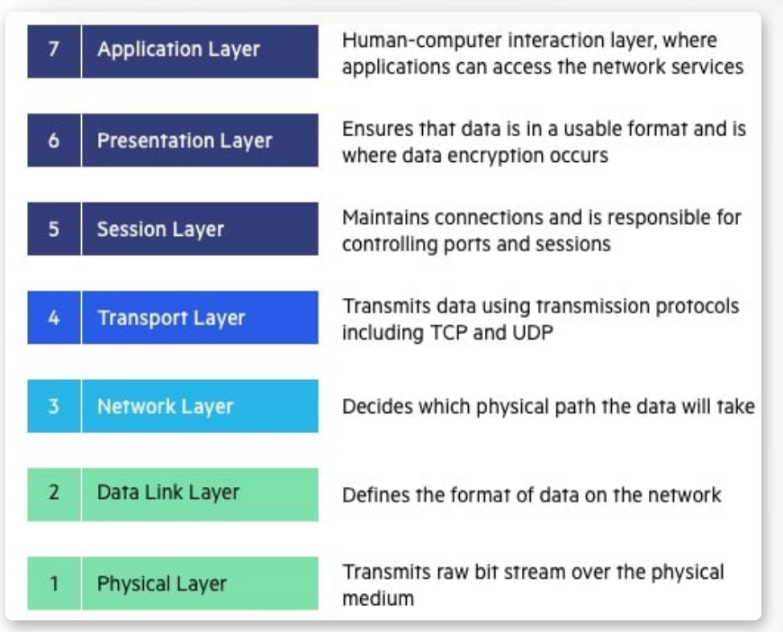
visual representation of each layer of the OSI Model

OSI divides the IT community. Called overly complex and impractical, many argue the 4 layer TCP/IP model is more flexible.

New models emphasise integrating new components and technologies. Deeming it makes the model more efficient, convenient and cost-effective. TCP/IP has flexible architecture unlike the rigid structure of OSI.
- A failure in lower layer of OSI can impact the functions of higher layers

Cyber security professionals need to understand the OSI model due to the framework for understanding how data is transmitted and processed over a network. Allowing professionals to identify potential vulnerabilities and implement security measures.

TCP/ IP Protocol
Communication between computers was more complicated at the beginning, each manufacturer had their own communication but not integrated or standardised with other computers. It quickly became apparent that a standard was needed. The standard is TCP/IP aka Transmission Control Protocol/ Internet Protocol
- IP is the part that gets the address to which data is sent
- TCP delivers the data once the IP address is found

How it works
Analogy: someone who gathers all the pieces you read and then puts the whole puzzle together

TCP/IP is a set of protocols that aids in exchange of information between origin and destination. Essential to defining transmission standards

When talking about TCP, refer to defining how applications manage communication channels over the network. It assists in breaking messages into pieces to later reconstruct. While IP defines addresses and paths for data packets. IP guarantees the information reaches the correct places. With these protocols the entire internet is addressed and information is able to be received and set.

Alternative Analogy: IP is a cell phone, TCP is the technology behind the phone and conversation.

What is the structure:
- OSI has 7 layers
- TCP/IP has 4 layers.
  - Application, transport, network and interface
  - First layer receives data, the second packs it, the third addresses it and the last sends data.

TCP LAyers
4. Application Layer
- Responsible for sending and receiving programs. Performs communication between TCP IP transport
  - HTTP (HyperText Transfer Protocol): transports HTML pages from web server to browser
  - FTP (File Transfer Protocol): transfer files, using login and password data between computers
  - SMTP (Simple Mail Transfer Protocol): used for transporting emails
  - DNS (Domain Name System): responsible for converting brower URL into IP used to identify location on the net.
3. Transport
- Serves to receive the data transmitted by application, analyze its integrity and divide into smaller packets
- TCP is most used in this step, indicated for connection
- UDP is unreliable, as it needs reliability and integrity of data
  - Aims to transmit media

2. Network
- A header is added to the data packet by the transport, containing the IP address of source and destination.
- IP protocol is the most important of this phase but it must pass through the interface layer first.

- Interface
  - Final layer
  - Characterised by the type of physical network to which the computer is connected. The physical connection is responsible for taking care of the physical aspect while complementing the work of TCP/ IP .
  - Task of the interface is to send and receive over the network.

Characterics of TCP/IP
- Interconnectivity - can connect different systems , promotes interconnectivity. Several utilities can access and transfer to different systems then originator.
- Standardisation - most accepted routable protocol by OSs
- Routing - allows old and new tech to connect
- Robustness - robust that can be used in OS performing applications between two points regardless of distant
- Internet - internet access requires TCP/IP to be configured to gain access. Promotes end to end communication and network reliability.

Additional Network Protocols
Set of norms and standards that make two+ machines connect to the network and web.
- Syntax - rep data format and order of presentation
- Semantics - meaning of each syntactic set that gives meaning to message
- Timing - defines an acceptable transmission speed

Principal Types of Network Protocols
For communication both computers must be configured correctly.
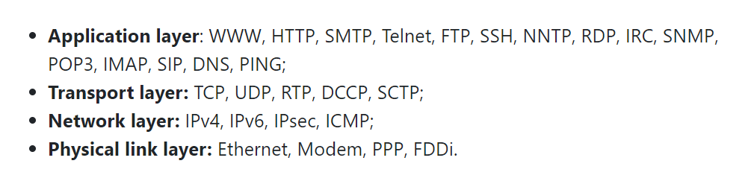

Main Network Protocols
- IP
  - Part of the internet layer, most important on the web
  - Allows prep and transport of packages without delivery
  - Recipient message is determined through fields of ip address, subnet mask, gateway field narrowed by default
- TCP
  - Transmission control protocol
  - Protocol stack is divided into 4 - listed above
- HTTPs
  - HTTP used for browsing sites
  - HTTPs works like HTTP but with an extra encryption
  - Commonly used with sites that payment, security is confirmed through digital certifications

- FTP - File Transfer Protocol
  - Simplest way to transfer data via network
  - Works between server and client
  - Helpful in case the user loses access to the website control panel. Thus tool used to adjust the page, add or delete files
- SSH - Secure Shell
  - Used for remote login and command execution on servers
  - Protects against eavesdropping, tampering and data theft
  - SSH provides other secure network services
    - Like Secure file transfer (SFTP)
    - Secure forwarding (tunnelling)
  - Widely used by admin, users to secure manage remote servers
- SSL - Secure Socket Layer
  - Secure communication by confirming the identity of a server. Checks about trust.
  - Sublayer of TCP/IP it worked by authenticating parties

- ICMP - internet Control Message Protocols
  - Authorises the creation of IP- related message, error messages and test packet
  - The OP does not correct the error but shows them to neighbouring layer protocols.
  - ICMP protocol is used by router to signal error called delivery problem
- SMTP - Simple Mail Transfer Protocol
  - Commonly used to transfer email from one server to another
  - Messages are captured and sent SMTP, forwarding them to final recipients in an automated and instantaneous process.
- TELNET - Teletype Network
  - Network protocol used for remote terminal emulation
  - Allows a user to connect to a remote network device and run commands
  - It is the standard internet protocol that allows you to interface terminals and apps
  - TELNET is based on TCP to send data in ASCII format encoded 8 bit, between telnet control sequences are inserted.

- POP3 - Post Office Protocol 3
  - Used to exchange electronic messages
  - Like email, the server stores messages and client authenticates for access. Thus messages stored on the server are transferred to the client's computer and when connection is terminated - messages are accessed in offline mode.
- IMAP - Internet Message Access Protocol
  - Aims to send and receive emails similar to POP and SMTP
  - However IMAP - allows user to access and manage files and message directly on the server itself
  - No need to wait for transmission from the server to client as clients directly access. Thus saving time and advances the work through the internet
  - Most popular email services use IMAP as a base
    - Including Gmail and Hotmail
- XMPP - Extensible messaging and presence protocol
  - XMPP is less populated but is often used.
    - With Signal, telegram or Whatsapp
  - Is open source communication used by instant communication programs
  - Due to simplicity and functionality combined with a security layer using end to end encryption - gained space in IoT - oriented applications.

- DHCP - Dynamic Host Configuration Protocol
  - Less known but everyone uses it. Many connections like local networks, wifi, hotspots, modems and some companies use it.
  - Simplifies network admin by automatically assigning IP addresses to devices.
    - Removing need for manual configuration of each device
    - Enables easy reconfiguration of devices
- DNS - Domain Name System
  - Decentralised system that translates human-readable domain names into machine-readable IP addresses.
  - Used whenever you access a website or subsection of a website
- RDP - Remote Desktop Protocol
  - Multi-channel protocol that allows users to connect to computers running microsoft terminal services.
  - Mostly windows and linux

- SIP - Session Initiation Protocols
  - Application that uses request-response model - sim to HTTP to initiate interactive communication sessions
  - Used to establish calls and conferences through IP protocols
- BitTorrent
  - Network protocol allowing users to download files, generally indexed on websites
  - Introduces the concept of sharing what has already been downloaded, maximising performance and high transfer rates.
- NAT - Network Address Translation
  - NAT is a technique used by routers to allow private network
    - Like home network or single public IP address
  - Private IP addresses are not globally unique and cannot be used to directly access the web

- IPsec - Internet Protocol Security
  - Set of protocols and algorithms to protect data transmission
  - Originally defined two protocols for securing IP packets
    - Authentication Header (AH)
      - Data integrity and anti-replay services
    - Encapsulating Security Payload (ESP)
      - Encrypts and authenticates data
  - Now includes internet Key exchange (IKE)
    - Generates shared security keys to establish security associations.
    - Security association requires encryption and decryption to negotiate level of security
- Ethernet
  - Connection protocol that manages devices on a LAN.
  - Common in corporate environments, facilitates exchange of info and files on the same network

Network Architecture
Network topology refers to physical or logical arrangement of devices and paths within the computer network, describes how devices are connected. Main types of Network Topology

- Physical Network
  - Refers to way cables are connected, like the position of machines, routers and gateways
- Logical Network
  - Examines and organises how machines interact with each other, describes the path data takes between devices

Basic network communication includes broadcast, multicast, unicast and point-to-point. Broadcast transmits info to all possible network destinations. Multicast departs from a single transmitter to multiple predetermined recipients. Unicast sends info from one transmitter to one receiver in a single direction. Point-to-point is when receivers and transmitters are connected.

Types of Physical Network Topology
- Star Topology
  - Most common configuration, nodes connected to central hub. Manages data over the network all data travels though central hub before arriving at destination.
  - Pros:
    - convenient management, devices added or removed without network interruption
    - Easier to id and isolate performance issue
    - If node fails the network still works
  - Cons
    - If central hub fails the whole network does
    - Central node limits performance and bandwidth
    - Can be expensive
- Bus Topology
  - Also known as backbone or line
  - Devices along a single cable runs from one end to the other
  - Pros
    - Cost effect for small networks
    - Simple layout (connected by cables)
    - More nodes can be added by lengthening the line
  - Cons
    - Vulnerable to cable failures
    - Each node slows transmission speed
    - Data is only sent in one direction at a time
- Ring Topology
  - Circular pattern
  - Data travels around the ring though each device. With large network repeaters may be needed to avoid packet loss.
  - Single ring (half duplex) or dual ring (full-duplex)
    - Dual ring allows flow of traffic in both directions
  - Pros
    - Cheap to install, easy id of performance issues
  - Cons
    - If node does down it can take multiple others
    - All devices share bandwidth thus limit throughput
    - Add or removing nodes means network being down for adjustment
- Tree Topology
  - Central node connects to secondary hubs. The hubs have parent-child relationship
  - Central axis = tree trunk and secondary hubs = branches
  - Pros
    - Very flexible and scalable
    - Easy id of errors as each branch can be diagnosed individually
  - Cons
    - If the central hub fails then nodes disconnect. (tho branches would function independently)
    - Structure can be hard to manage
    - Uses more cabling than other methods
- Mesh Topology
  - Nodes are interconnect
  - Full mesh connects all devices on network directly. While part mesh connect most devices. Allows data to travel the shortest distance available for transmission
  - Pros
    - Reliable and stable
    - No single node failure cause the network to go down
  - Cons
    - Complex degree of interconnectedness
    - Labour intensive to install
    - Lots of cabling to connect
- Hybrid Topology
  - Uses various topology structures
  - Common for large companies where each department may have there own structure that connects to a central hub
  - Pros
    - Flexibility and customizable
  - Cons
    - Increased complexity
    - Experience in multiple topologies required
    - More difficult to see performance issues

Peer-to-Peer (P2P) network
Connects approximately equal computers on equal basis without a third computer. Different from Client/server networks, P2P are usually located close together and run similar hardware and OS.
- Before home networks → only offices and schools built P2P.

When people hear of P2P often think of peer-to-peer fil sharing like Napster, Kazaa, eMule and bitTorrent.

Reasons to understand network Topology due to Cyber Security
- Vulnerability assessment - used to identify weak points and potential attacks
- Network performance - significant impact on performance (speed and reliablity). Helps to understand ideal optimization of the network
- Network design - could be involved in designing or implementing new networks
- Troubleshooting - in an outage, security must know network topology to diagnose and resolve the issue.

Network Security Basics
Questions to answer…
- What is network security?
- Why do companies need network security?
- How do companies implement network security?
- What are some common types of network security? (you may wind up with a list of 10-15 types)

Articles to Read
- 11 Effective Types of Network Security Protection (from Cyber Hunter)
- Network Security Basics (from IEEE Security & Privacy)
- Network Security: What Is It, Why Does It Matter and What Can You Do to Make Networks More Secure? (from CompTIA)
- The Different Types of Network Security (from Alliance Technology Partners)
- What is Network Security? (from Check Point)
- What is Network Security? (from Cisco)
- What is Network Security? (from IBM)
- What is Network Security? Types of Network Security Measures (from EC-Council Cyber Security Exchange)

Understanding IP Addresses
Each connected device has a unique IP address, allowing communication between devices on the network.

What is an IP address? (IPv4)
Is a sequence of numbers consisting of 32 bits. Value consists of four 8-bit strings, called octets or bytes - each separated by a dot.

192.168.0.1 is an example of an IP address. Each octet is a number from 0 to 255.
The first octet is 192
Having four parts of an IP helps organise the network in the same way dividing your address into a whole address. The first two octets are used to identify the network. While the last two octets are used to identify the individual computers.

IP address classes
Home networks may have the same IP addresses that on another network already exist. It is okay due to home networks not communicating with each other. While the internet must have unique IP addresses as each device must be identifiable by the internet as it is a global network.
- If two or more devices have the same IP address on the internet then, there is an issue. Called an IP conflict, which hinders or prevents communication between these devices and can interrupt the whole network.

For IANA - internet assigned numbers authority
ICANN - internet corporation for assigned names and numbers.

The two distribution schemes divide addresses into three main classes and two complementary classes.
- Class A:
  - Used where few networks are needed but many machines are on them
  - First byte is used as the network identifier, allowing up to 128 networks each with up to 16,777,214 connected devices.
  - 0.0.0.0 through to 127.255.255.255
- Class B:
  - Used where the amount of networks in equivalent or similar to the number of devices
  - The first two bytes of the address are used to identify the network, and remaining octets the specific device
  - 128.0.0.0 through to 191.255.255.255
    - Allows up to 16,384 networks and 65,536 devices on each

- Class C:
  - Used in locations requiring many networks with few devices on each.
  - First three bytes are used to id network. Last is for devices.
  - 192.0.0.0 to 223.255.255.255
    - allows up to 2,097,152 networks, each with up to 254 devices
- Class D and E:
  - Exist for particular reasons - D for propagating special packets between devices and E is reserved for future or experimental applications
  - D: 224.0.0.0 to 239.255.255.255 — multicast;
  - E: 240.0.0.0 to 255.255.255.255 — reserved multicast.

- Special cases
  - Addresses starting with 127 indicate a fake network, used only for testing.
    - 127.0.0.1 refers to device itself aka a localhost
  - 255.255.255.255 is used to broadcast messages to all network hosts simultaneously.
- Private use only
  - they cannot be used over the internet as they have been reserved for local applications. These are:
    - Class A: 10.0.0.0 to 10.255.255.255;
    - Class B: 172.16.0.0 to 172.31.255.255;
    - Class C: 192.168.0.0 to 192.168.255.255.

To manage a network of 50 computers - you don't add one more IP for each. Need to connect to the network via server or equipment. Only after the process will the equipment access the network.

Subnet Mask
IP classes help address organisation, but can be wasteful. To solve this, the subnet mask - a resource which changes an intended octet (to identify connected devices) to increase the network capacity

Subnet mask allows to determine how many octets and bits are intended for network identification.

****review and go over Subnet masks**************

Difference between fixed IP and dynamic IP
Fixed IP or static IP is an address permanently assigned to a device. The device will always have the same IP, even if it is disconnected - the IP only ceases to be fixed if it is changed manually

Dynamic IP is assigned to a device when connected to the network. Each time there is a new connection, the router that controls the network will assign any available IP to the device. Can reserve the same IP for the same device but will not reserve it exclusively.

IP on websites
For every website address the DNS server is consulted, finding the corresponding IP address for the request. To find the IP of a website you can use a windows computer and type cmd to get the command prompt. Then use ‘ ping www.thesiteyouwant.com ‘ to get the IP address.

IPv4 versus IPv6: the later has more potential addresses to support the ever growing IoT.
IPv6: Five Things You Should Know

Internet Service Provider (ISP)
ISP is an organization that provides access to the internet, connected though access points in the internet’s backbone. May also offer Email accounts, DNS, website hosting or building, Voice over IP (VoIP).

ex) WISP, simpler to establish and mainly employs radio towers and short-range antennas. Offers good wifi speed to rural communities and allows streaming.

Cyber Security Frameworks and Roles

Team: overview
Cyber security at three levels
- Entry Level
  - Some degree or skill requirements, not extensive experience or specialized training.
  - ex) Cyber security Analyst: protects a company’s networks and systems. Installs software and reviews sus activity to follow cyber security trends.
- Specialized experience: Management
  - Leads a team of people, plans and organizes. Responsible for the bigger picture and forward-thinking plans. Usually needs prior experience
  - In big companies - roles between entry and management (team lead or specialist..)
  - ex) Information security Manager
    - Maintains security protocols, identifies security risks, and makes sure software and infrastructure is protected. Leads internal training and policy. Manages security testing platforms and forensic investigations.
- Top of Field: C-Level
  - C stands for Chief and usually experts in the field.
  - They drive vision, structure, long-term plans, and are the main person for department success.
  - Levels between ate senior manager, directors, senior and VPS.
  - Ex) CISO
    - Responsible for the information systems and security department. Npt only manage the function but work closely with other exec leaders to advise and make decisions of security.
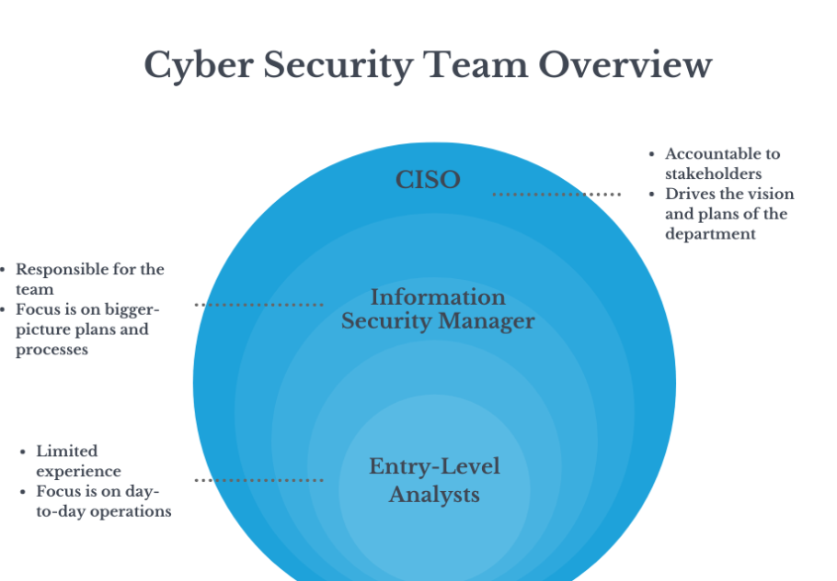

Job: Roles and Responsibilities
https://web.compass.lighthouselabs.ca/p/14/workbooks/cyber-ft-prep/activities/2461
- Incident responder
- Manager
- Operations Analyst
- Information security analyst
- Information security engineer
- Penetration tester
- Vulnerability assessment analyst.
Twenty Coolest Cyber Security Careers
Cyber Security Career Pathway

Cyber Security Team: Aligning goals
Critical thinking reminder

Choosing a Cyber Security Framework
Things that can influence the framework chosen. Entry-level does not usually impact the decision or direction the company moves towards.
- Geography: where does your organization do business? Are there national or international regulations to consider?
- Industry: is your industry highly regulated? Are there mandated industry-specific frameworks you must follow?
- Size of organization: are you a small, medium, or large company? Are you projected to grow significantly in the near future?
- Achievability and iteration: is your organization ready for a complex framework, or is it helpful to begin with a more achievable model first?
- Expertise or preference: all else being equal, is your team more comfortable with a particular framework? Would they be more successful in implementing one in particular?

Using a Cyber Security Framework
When faced with a complex and detailed framework, it may be tempting to ignore the ideas but it is best to fully understand and apply the right framework.

Advantages of a framework
- Comprehensive approach
  - Useful guides to help determine security needs, controls and long-term implementations. Often a key area for CISO and their team
  - Most frameworks provide guidance with..
    - Inventory of current security measures used
    - Analysis of existing and possible risks and vulnerabilities
    - Assessment of value of info and assets protected
    - Identification of organization’s risk tolerance levels
  - This helps the security team plot elements out in order of need, and select the right protections and training to limit risk.

- Blind Spots
  - No team is ever without its blind spots
  - Most frameworks contain hundreds of criteria or categories to consider
  - Applying a framework may highlight areas of consideration that are not at the top of your own mind or team’s.

- Compliance (within Limits)
  - Industry dependent compliance standards to ensure security of information.
  - Industries that are highly regulated usually have their own compliance frameworks to be implemented
  - May need to cross reference between the industry standard and a more general framework that suits the company's goals.

- Same Page
  - Advantage of a framework is everyone is agreed and on the same page
  - Common set of criteria with shared language to effectively communicate requirements and best practices
  - Many cybersecurity frameworks organize standards into high-level categories that can be more digestible guidelines outside of the cyber security team.
    - Can help with cross-department buy-in for security

- Human Factor
  - While frameworks offer guidelines to support the team, need to remember it is not fool-proof. Subject to interpretation.

Thinking Critically about Frameworks
Why the Cyber Security Framework Will Make Us Less Secure

- Does the article affect your perspective on the advantages of using a Cyber Security framework?
- This paper was written in 2014. How do you think the Cyber Security landscape has changed since then? How does that impact the arguments the authors put forth?
- How might this affect your approach to choosing or applying a Cyber Security framework?

Cyber Security Framework Components
Three main components are identified by NIST
- Framework Core
  - Set of desired cybersecurity activities and outcomes aligned with information references. Designed to be intuitive and be a translative layer to communicate between multi-disciplinary teams with simple non-technical language.
  - Set of core principles and purposes, OFten detailed parameters into digestible high-level categories.

- Implementation Tiers
  - The degree the organizations risk management practices exhibit framework characteristics
  - Frameworks may have implementation steps, levels or cycles
  - Helps identify need or capacity of organization and where it fits in implementation

- Framework Profiles
  - The companies’ unique alignment of requirements, objects, risk appetite, resources against desired outcomes of the core

Get to know some Frameworks
Looking through some key cyber security frameworks. Should aim to become familiar enough to name, outline and explain the framework to a friend

- NIST Cybersecurity Framework (CSF)
  - Developed by NIST
  - Widely used for managing cybersecurity risks
  - Notes: provides common language for understanding and managing risks, designed to be flexible and adaptable to needs of different organizations
- ISO/IEC 27001
  - Developed by ISO (international organization for standardization) and IEC (international Electrotechnical commission)
  - Set of standards for establishing, implementing, maintaining and improving information security management system
  - Notes: standards in ISP/IEC 27001 are established by international committee and regularly updated

- COBIT
  - Developed by ISACA
    - Information system audit and control association
  - Best practices and guidelines for IT governance, risk management and control
- CIS Controls
  - Developed by CIS
    - Central for internet security
  - Set of best practices for protecting against cybersecurity threats
  - Notes: controls are organized into 18 categories and designed to be prioritized and implemented based on needs of the organization
- MITRE ATT&CK
  - Developed by mitre corporation
  - Documents tactics, techniques, procedures used by cybercriminals and some resources to help detect and migrate attacks
- Security Information and Event Management (SIEM)
  - Set of tools to provide aggregated info and analysis of real-time threats to the networked system
  - SIEM solution does not constitute a self-contained cyber security framework. But can help to automate part of monitoring and detection.
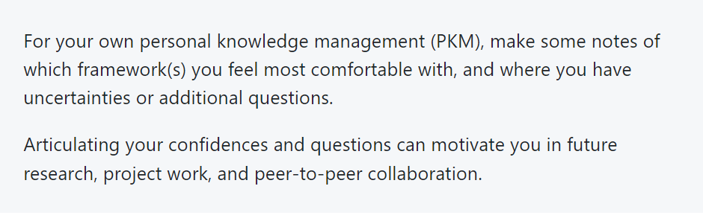

Blue vs Red Teams

Offensive and Defensive Security
Blue team can be considered defenders of the castle. Focused on defensive security, determines and implements the right security measures and monitors new incidents.
Job titles related to blue team
Cyber Security Analyst, Incident Responder, or Cyber Security Engineer

Red team adopts the POV of the attacker. Focused on offensive security, finding any ways in or loopholes. Aim to identify weaknesses in the system and how they may be exploited.
Job titles related to red team
Penetration Tester and Red Teamer.

There tends to be more blue team jobs then red, no exactly equal job market. Purple exists to be between both teams (do it all).

Red Team vs. Blue Team in Cybersecurity
Take Control of Your Learning: As you read, write down 3 questions that the article generates for you. As you move through this course (and your own research), see if you can find the answers!

Role of the Blue Team
Focus on defensive security, identifies key security needs and implementing measures needed to maintain the security and reliability of the network.

Risk Assessment
NIST defines a risk assessment as the process of identifying risks to organizational operations, assets, individuals and other organizations. Part of risk management, incorporating threats and vulnerability analyses. - Source

Incident response
IBM defines incident response as an organization's processes for detecting and responding to cyberthreats, breaches and attacks. Goal is to prevent cyberattacks before they happen or minimize costs.

Most cyber security teams have a carefully planned incident response protocol allowing them to confidently sprint into action upon any threat

Read IBM’s full article about Incident Response
Consider the industry or area of business that you might be interested in working for as a Cyber Security professional. Would any of the incident response technologies listed in the article be more or less beneficial to your preferred situation? Choose one or two of them to research more fully.

Forensic Analysis
Forensics can help security figure out how an attack occurred. Involves collection and analysis of key digital evidence in order to trace attackers. May also help to retrieve lost information

Monitoring
Blue team monitoring is key to ongoing cyber security. As technology evolves and changes procedures of the company, a cyber security plan is never one and done.

System or network needs to be regularly checked and monitored by a combination of automated tools. Monitoring helps identify new vulnerabilities or attempted attacks as they occur.

Read: Are Blue Teamers the True Heroes

Defensive Security Measures
Looking at common security measures, techniques and tools used by the Blue Team.

- Antivirus and Anti-malware software
  - Scans a device for malicious software. Once detected, the software can remove the danger before it causes harm to the device. Can also be preventive to stop new malicious software from being installed
  - Situation: risk assessment, monitoring, prevention
  - Helpful by..
    - Providing security for individual devices from viruses and malware
    - Minimizes damage on an organizational level if a malicious software is deployed.
- Digital Footprint Analysis
  - Digital footprint analysis allows you to see the trail of actions connected to a user to determine if identity of user is authentic
  - Situation: incident response, forensic analysis
  - Helps by..
    - Expose potential fraud and identity theft
    - Tracking down the cybercriminal behind an attack

- Domain name server audit (DNS)
  - DNS audit scans IP addresses connected to organization to check for errors, as connect to domain names
  - Risk assessment and monitoring
  - Helps by..
    - Reduces chances of phishing and DNS attacks
    - Identifies out of data DNS entry points
    - Prevents domain hijacking

- Endpoint Protection Platform (EPP)
  - Endpoint security software scans the endpoints for suspicious activity. “Endpoint” refers to any device that can be the initial or final point for data transmission.
  - Risk assessment and monitoring
  - Helps by…
    - Detects sophisticated attacks like APT
    - Goes beyond antivirus software to detect other potential threats
- Firewall
  - Firewall is hardware or software that acts as a gateway for an organization's network traffic. Controls access according to security requirements
  - Monitoring and prevention
  - Helps by…
    - Prevents unauthorized access to a network
    - Acts as a barrier between private and public networks
- Intrusion Detection System (IDS)\
  - IDS is a device or software that provides 24-hour monitoring of a network. Search for suspicious activity. If unusual activity is detected and admin is alerted.
  - Incident response and monitoring
  - Helps by…
    - Provides consistent monitoring beyond business hours
    - Acts as an early warning system, allowing admin to make decisions about how to respond.
- Memory Analysis
  - Memory analysis is the process of seeing snapshots of a computer’s memory to look for evidence that indicates an attack
  - Incident response, forensic analysis and monitoring
  - Helps by…
    - Identify attacks that may be undetectable elsewhere in the system
    - Helps forensics to determine attack method

- Network Segregation
  - Involves identifying critical networks, hosts or systems and applying separate sets of access controls
  - Risk assessment and prevention
  - Helps by…
    - Safeguards critical content, data and info from a widespread attack
    - Allows varied security measures depending on sensitivity of data.
- SIEM solutions
  - Security info and event management solutions
  - Is software (cloud or inhouse based) that analyzes activity across different parts of the system to give holistic picture of the security of the system
  - Risk assessment, incident response, monitoring
  - Helps by…
    - Catches threats early, quicker response without loss of business
    - Comprehensive visibility of the security situation

- Vulnerability Scanning Software
  - Vulnerability scanning software scans aim to identify potential weaknesses in all areas. NEtwork, firewall, printers, etc.
  - Internal (finding weakness within the system or network) or external (weaknesses that allow someone to attack the system)
  - Risk assessment, monitoring, prevention
  - Helps by…
    - Identifies inside threats
    - Detects many vulnerabilities through frequent scanning

Role of the Red Team
Red team focuses on offensive security and will explore key processes to identify vulnerabilities and exploit weaknesses in network security

Attempting to breach Walls
Red team aims to find weaknesses in security, some measures taken is POV of a hacker on companies’ behalf. Sometimes called ethical hacking.
helpful history of how Ethical Hacking came to be

Fact-finding and analysis
Large part of red team’s role is gathering and processing information about systems. Seeking to gather information about..
- Physical devices across the organization that are connected to the network (including employee computers, servers, smart devices, printers, etc.)
- OSs in use across the organization (including updates and versions)
- A full picture of network hosts and connections and usage traffic patterns
- Network security systems in place (including firewalls and access restrictions)
- Physical security systems in place (including entry key cards, camera systems, security guards)
- Employee awareness (including real-time application of training or intuition)

Additionally to analyze the information gathered. Including vulnerabilities, prioritizing risks and making reports for the blue team and leads for directional guidance.

Read this article from Ars Technica → can red team roles’ be automated.

Offensive Security Measures
- Penetration Testing
  - Referred to as Pen testing or ethical hacking. Is coordinated effort to simulate an attack on a system or network to expose weaknesses.
  - Revelate area:
    - Internal Network Connections, Devices, OSs, Access Points, Physical Security, Information Transfer, Employee Awareness
  - Helps by…
    - Exposing vulnerabilities
    - Tests the incident response plan

- Password Cracking Software
  - Password-cracking tools can be used to uncover passwords and hack user accounts. They run common passwords and patterns with different usernames.
  - Revelate area: internal Network connections, Devices, access points, employee awareness
  - Helps by…
    - Highlight weaknesses in system’s password security requirements
    - Identify user accounts with easily hacked passwords

- Social Engineering and Phishing
  - Red teamers will employ social engineering techniques to test the resilience of an organization's employees to these attacks
  - Revelate area:
    - Access points, employee awareness
  - Helps by…
    - Determines the risk potential of social engineering attack
    - Highlights areas where staff training and awareness may be needed

- Packet sniffer
  - Also called protocol analyzer
  - The tool looks at data that transits between devices. This could be simple as intercepting emails or tracking website visits
  - Revelate area:
    - Internal Network Connections, OSs, Information Transfer
    - Helps by…
      - Identify areas where dat may not be effectively encrypted
      - Show movement of data to support more complex diagnoses.

- Card Cloning
  - Makes it easy to retrieve and copy data from a company security card or ID badge. Red Teamers may used these tools to test vulnerabilities of access cards
  - Revelate ares:
    - Physical security, information transfer, employee awareness
  - Helps by…
    - Expose weaknesses in badge security system
    - Highlights area where staff training and awareness may be needed

Attack Simulations
Sometimes a cybersecurity team will carry out a real time fake attack to test their defense security measures.

Timeline of simulation
- Typical day: with blue team monitoring the system
- The security warning flashes, a virus is loose in the system
- The blue team springs into action and initiates the incident response.
- Meanwhile..
  - Down the hall - red team are hard at work
  - After months of gathering info have highlighted key areas of vulnerability
  - With knowledge of their leadership - they launched an unexpected attack to see current incident response protocol
  - The red team released the virus, exploiting a port left open by recent update
  - The blue team doesn't know the virus is harmless.
- Blue team works quickly and collaboratively to deploy defensive measures
- After awhile the virus is contained by the blue team
- After the simulation
  - Both teams join to share and analyze the information gathered
  - They identify vulnerabilities that allowed the attack
  - Dissect the effectiveness of response.

Dev Environment

Dev Environment
No downloads at this unit, just walking though to get familiar - more details, downloads and in-depth how to’s later into the course.

Will access tools and resources in two key ways
- EVE
  - Through emulated virtual environment provided by LHL
  - Provides access to multi-vendor software and hardware without having to download to your machine
  - By completing labs in EVE and utilizing software, we don't put additional strain on your personal computer

- External tools
  - For practical hands-on exercises, may need to use external industry relevant tools or open resources.

During the first lecture, will be provided with a demonstration of EVE and login information.

Virtualization Overview
Due to hardware virtualization, EVE provides students with access to VMs that provide CPU, memory, storage which are allocated to students. Makes it possible to use another physical machine’s full capacity and by isolating VMs from one another to protect against malware.

Operating System Virtualization
Additionally OS virtualization involves tailoring a standard OS so that it can run different applications handled by multiple users. OS is altered so that it operates like several different, individual systems. The virtual environment accepts commands from different users running diff apps.

With access to VMs, there is no need to download expensive software or upgrade your systems.

You will have access to the following:
- A Full network
- Dedicated VMs
- Kali VM
- Windows server OS
- Windows workstation OS
- Firewall appliance
- Linux OS
- Routers
- Switches
- Apache web server
- VS Code with Python
- Wireshark
- Spiceworks
- Paessler PRTG
- Snort
- Wazuh
- GPG4Win
- NMap / ZenMap
- OSSEC
- OpenPGP

Labs must be completed using EVE.

First 20 minutes of this video as prep: Type 1 vs Type 2 Hypervisors: What’s the difference?

EVE overview

Virtual Labs and importance of Cyber Security
Virtual training labs are reliable ways to ensure that professionals are up to date, proficient with industry software. Additionally provide hands on training by simulating IRL threats.

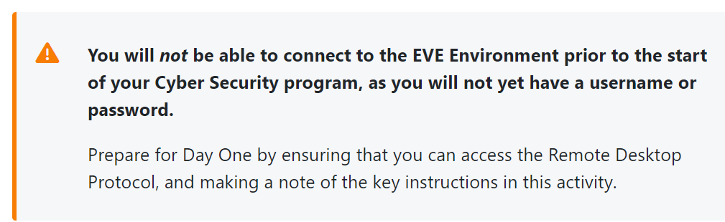

EVE environment - overview
Lab access will only be available once the program begins, so following is information only.

- Eve consists of 3 systems
  - Jumphost, EVE server, gateway, network space
- Jumphost
  - It is a windows server, used as endpoint for EVE network
  - Connect remotely - using RDP protocol
    - Its a public IP address an assigned port number as well as username + password
- EVE server
  - This system is bare metal, hosts the VE and is a linux-based system.
  - The based system the rest of the virtualized systems run on
- Gateway
  - Is the network’s connection to the internet
- Network Space
  - No details about it yet.

Setting up remote Desktop Protocols
To get RDP installed on windows OS

Start RDP on a windows based system, click your Windows Menu and type RDP. Hit Enter on your keyboard.
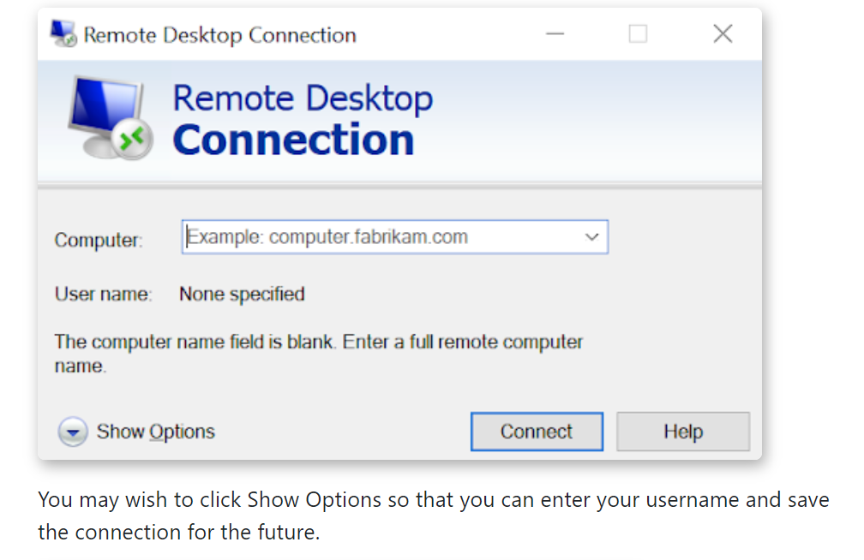

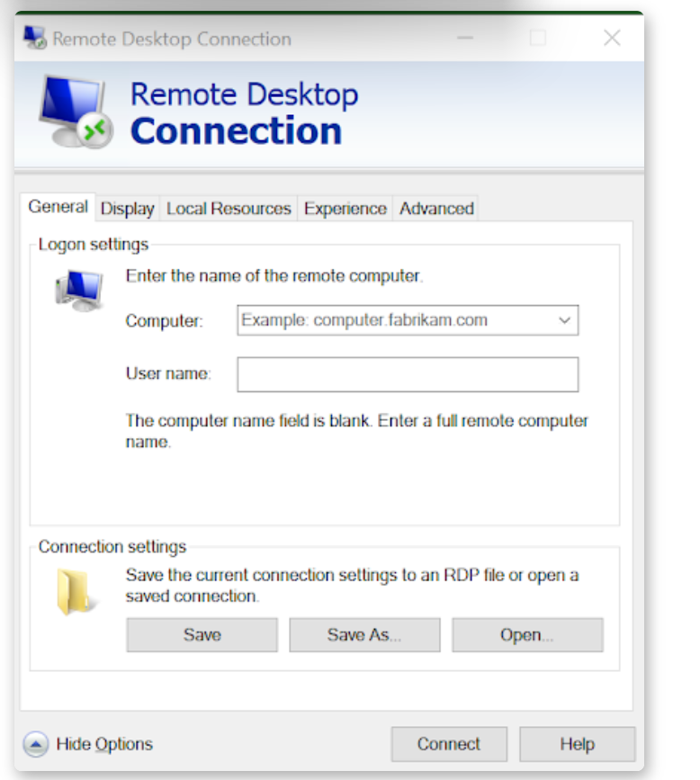
2. Enter the IP Address and port, separated by a colon, for example 111.222.111.011:123456 and the username assigned.

- Click Save As and give the file a name like LHL.rdp. You may want to save this to your desktop.

- You will then be asked to enter the user’s password.

- Once the password provided to you is entered, click Connect and you will connect to your EVE Jumphost.

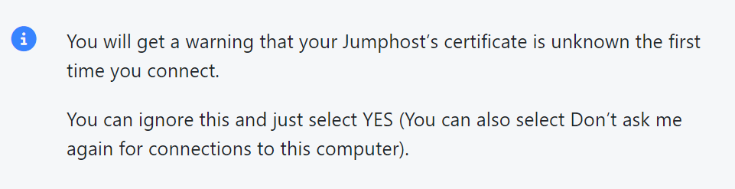

Intro to Visual Studio Code
VS code for short is a cross platform code editor written in TypeScript based on Code OSS. While not required to learn advanced programming languages while in LHL, the editor can help to input code that will be provided, and debugging.

Already downloaded
Optional Videos
- Watch the Getting started with Visual Studio Code video to learn more about its features.
- Review these short video resources to learn tips and tricks.
- OPTIONAL: Read the following Python in VS Code tutorial to learn more about using Python programming in VS Code.
- If you would like to follow along and feel confident that you can carry out these steps, then use this tutorial Free Python Tutorial for Beginners

Intro to MITRE ATT&CK
Youtube overview of what MITRE ATT&CK is..https://www.youtube.com/watch?v=WmQPtk3Ybxs

The MITRE ATT&CK framework provides guidelines for describing cyber attacks. MITRE is a company and ATT&CK stands for Adversarial Tactics, Techniques, and common knowledge.
It is widely adopted by organizations that need string IT security team.
- MITRE ATT&CK is used worldwide across multiple disciplines including intrusion detection, threat hunting, security engineering, threat intelligence, red teaming, and risk management.

Intro Video recommended
MITRE ATT&CK Framework Overview

Article to read
Getting Started with ATT&CK: Threat Intelligence
- Level 1 for those just starting out who may not have many resources,
- Level 2 for those who are mid-level teams starting to mature, and
- Level 3 for those with more advanced cybersecurity teams and resources.

Exploring ATT&CK Matrix for Enterprise - look at the 16 categories of adversary tactics and subcategories.

Intro to Wireshark
Wireshark is a network packet analyzer, presenting captured packet data with as much detail as possible. Comparable to a measuring device for examining network cable signals.

Before wireshark, such tools were expensive. Now thanks to wireshark, its free open source and one of the best packet analyzers available.

Uses
- Network administrators use it to troubleshoot network problems
- Network security engineers use it to examine security problems
- QA engineers use it to verify network applications
- Developers use it to debug protocol implementations
- People use it to learn network protocol internals

Readings
- To learn more about Wireshark’s intended purpose, features, how live capture works and network types supported on various platforms, read Chapter 1.1 Introduction to Wireshark.
- If you would like to learn more about System requirements, read Chapter 1.2.

Intro to PAESSLER PRTG Network Monitor
PRTG: Paessler router traffic grapher

PRTG network monitor is network management software for bandwidth, usage and availability. Helps ensure systems are running smoothly with no outages. Key to increased efficiency of the network by understanding bandwidth and resource consumption.

Consisting of a PRTG core server and one+ probes it can monitor almost anything with an IP address.

- the PRTG core server is responsible for configuration, data management, PRTG web server, and more.
- Probes collect data and monitor processes on devices via sensors.

Recommended Reading
To learn more, read the eight short topics listed on Paessler’s website PRTG Manual: Introduction: Monitoring with PRTG.
- What PRTG Does
- How to Monitor with PRTG
- What PRTG Monitors
- How to Prepare Monitoring
- Which Hardware Do I Want to Monitor
- Types of Logins and Credentials
- Monitoring Technologies
- Notifications from PRTG

Intro to SIEM
SIEM = Security and information event management technology
Made by Gartner

It collects data produced by security devices, network infrastructure, systems and apps, combined with contextual info to give a larger picture. Major advantage of SIEM is that data can be normalized so information from disparate sources can be analyzed.

The technology provides real time analysis of events for security monitoring, query, and long-range analytics for historical review. SIEM is a well-rounded security solution to help id vulnerabilities before they cause disruption.

Advanced threat detection w SIEM
Helps to detect, mitigate and prevent advanced threats including… Malicious Insider, data exfiltration, outside entities.

SIEM can use browser forensics, network data, authentication, etc to id insiders planning attacks. For Sensitive data transferred outside of the organization, SIEM can pick up transfers of unusual sizes, frequencies or payloads. As well, SIEM detect early warning signals indicating outside entity is carrying out a long-term or focused attack.

Readings: SIEM – Security Information and Event Management Tools – A Beginner’s Guide

Intro to SNMP events
SNMP = Simple network management protocol

It is a network protocol used for management/ monitoring of a network connected devices in IP networks. SNMP is embedded into multiple local devices like routers, switches, servers, firewalls, wireless access points, etc. Providing a common mechanism for network devices to relay management information within single and multi-vendor LAN or WLAN.

SNMP is a application layer protocol in OSI model framework

Concepts & components
SNMP defines a method of communication between various networking devices and a central manager.

There are three main components defined by SNMP
- SNMP manager
  - Central system that is used to monitor traffic by various SNMP agents. Provides mechanism for the control of these agents
- SNMP agents
  - Software component that exists within a network element.
  - Used to maintain real-time information about the elements’ operations. Used to communicate information back to central as well perform control actions dictated by SNMP manager
- Management information Base
  - MIB for short
  - Virtual info storage where network management information is help.
  - Within the MIB are different collections of objects that relate ( database vibes). Each collection contains a number of variables that can be altered by the agent or manager.

Read:
SNMP - Simple Network Management Protocol
Note SNMP versions, runtime, useful commands and limitations.

Intro to Command Line
INTRODUCTION TO THE COMMAND LINE - Launch School

Command Cheat Sheets
Linux commands
Command Line Cheat sheet
Linux Bash Shell Cheat Sheet
The Linux® Command Line
Linux Quick Reference guide
Bash scripting cheat sheet

PKM – look into it

